

MAJOR PROJECT OF CLOUD COMPUTING-1

# UNDER THE GUIDENCE OF

SHWETHA MAM

RUDDO INTERNSHIP

# SUBMITTING BY

CHETHAN R

MAHARAJA INSTITUTE OF TECHNOLOGY

MYSORE

# DETAILS

PHONE NO - 9538218404

[EMAIL_ID - chethanrgowda02@gmail.com](mailto:EMAIL_ID%20-%20chethanrgowda02@gmail.com)

## DATE OF SUBMITTING – 15/07/2024

# DAY – MONDAY

CONTENTS

1. Set Up S3 for Static Content.

2. Set Up RDS for Database and connecting with ec2 and creating database.

3. Set Up a Load Balancer and autoscaling.

INDEX

|  |  |  |
| --- | --- | --- |
| SI.NO | TITLE | PAGE |
|  | SET UP S3 FOR STATIC CONTENT | 1-8 |
|  | SET UP RDS FOR DATABASE & CONNECTING WITH EC2 AND CREATING DATABASE | 9-22 |
|  | SET UP A LOAD BALANCER AND AUTOSCALING | 23-48 |

# Set Up S3 for Static Content.

1.open aws account.

2.search s3 and select s3,create bucket and give a bucket name ,enable public all access, in a object ownership enable the ACLS, and leave others as default, and create bucket.

3.then select the bucket and upload files and folder, upload a image from a your system to files then upload a folder.

4.in a bucket go for the properties and edit wed static hosting then give a name example index.html and leave others setting as default and save changes.

5.go for the bucket and select the bucket you uploaded the image and select actions there u have to select make public using ACL and make public.

6.then copy the object url from the bucket file and paste that in browser it will show uploaded image .

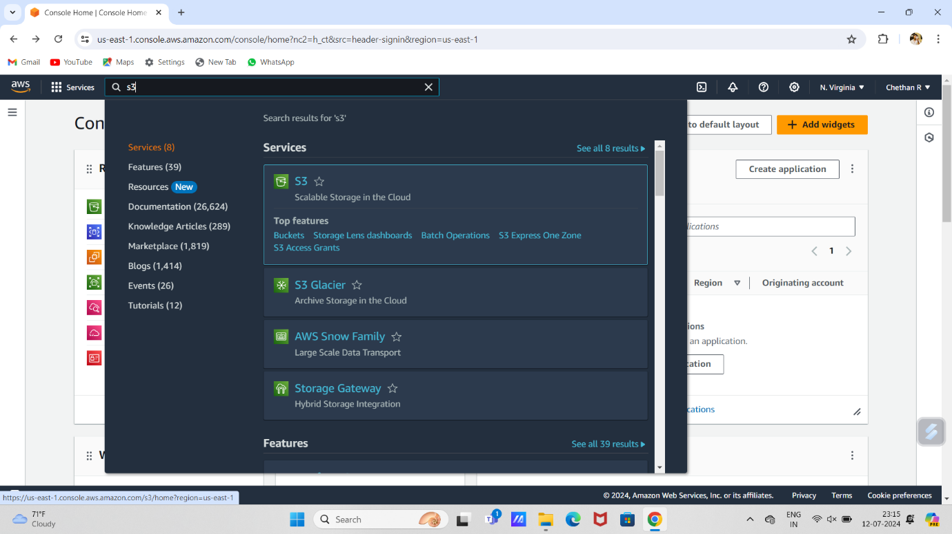

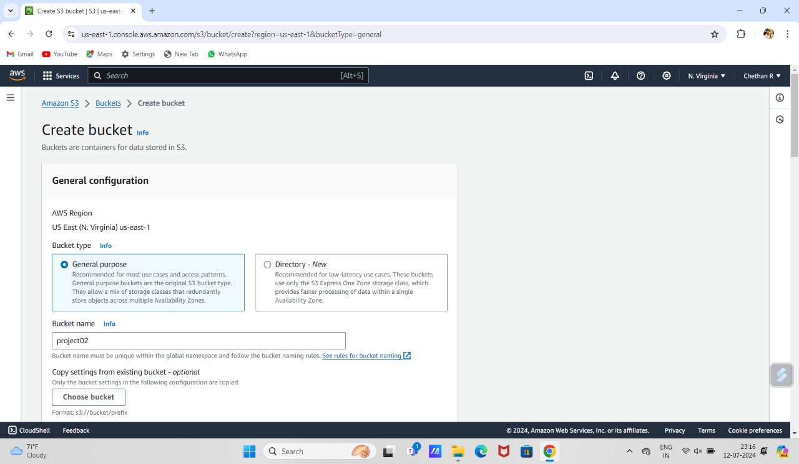

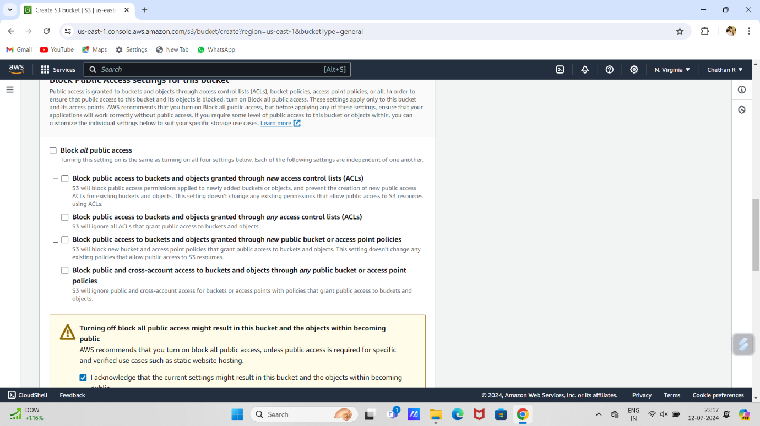

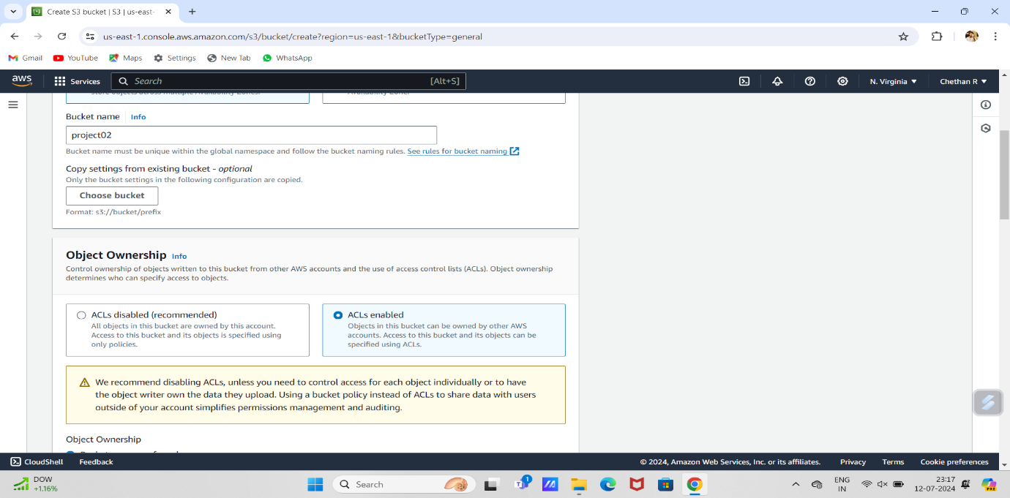

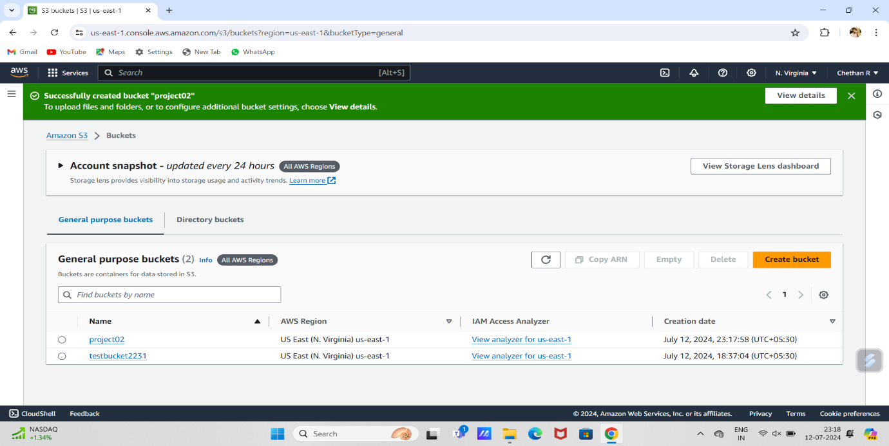

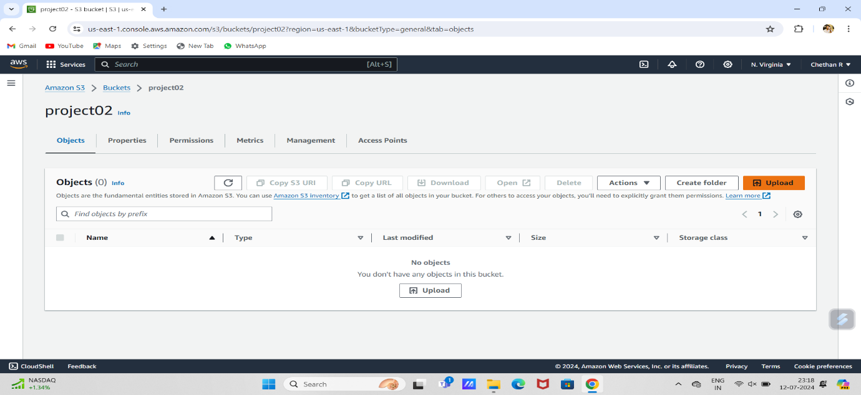

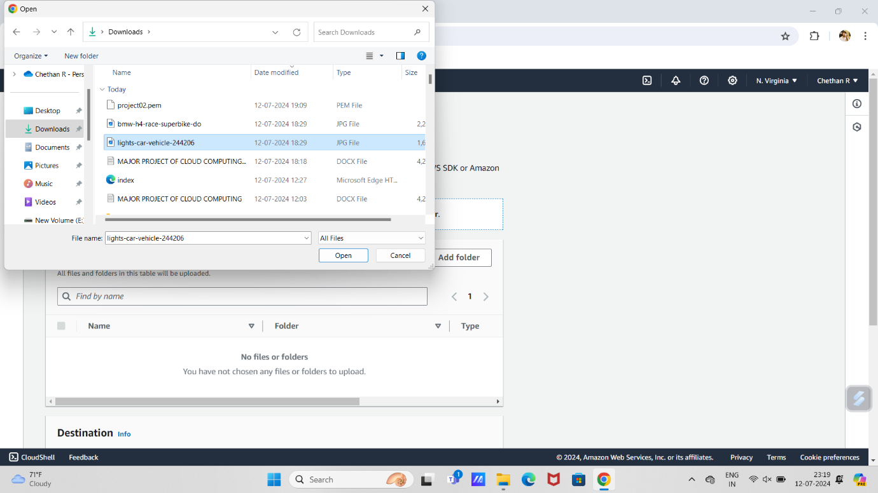

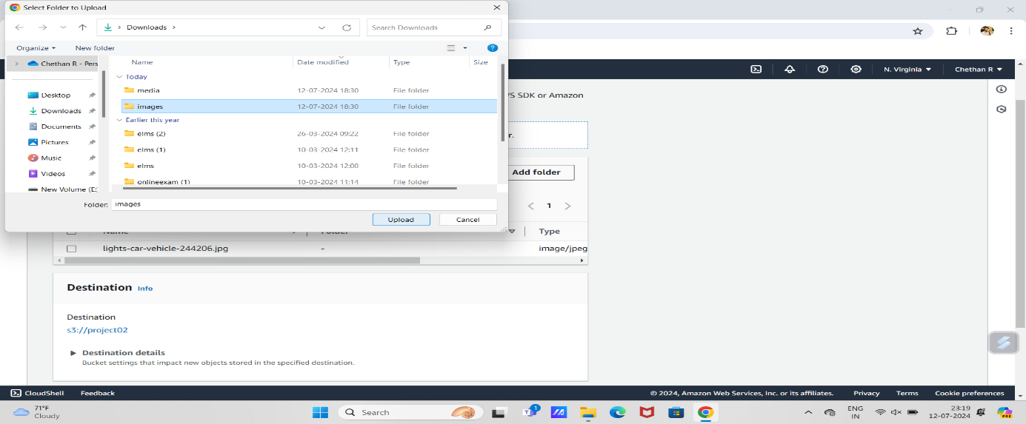

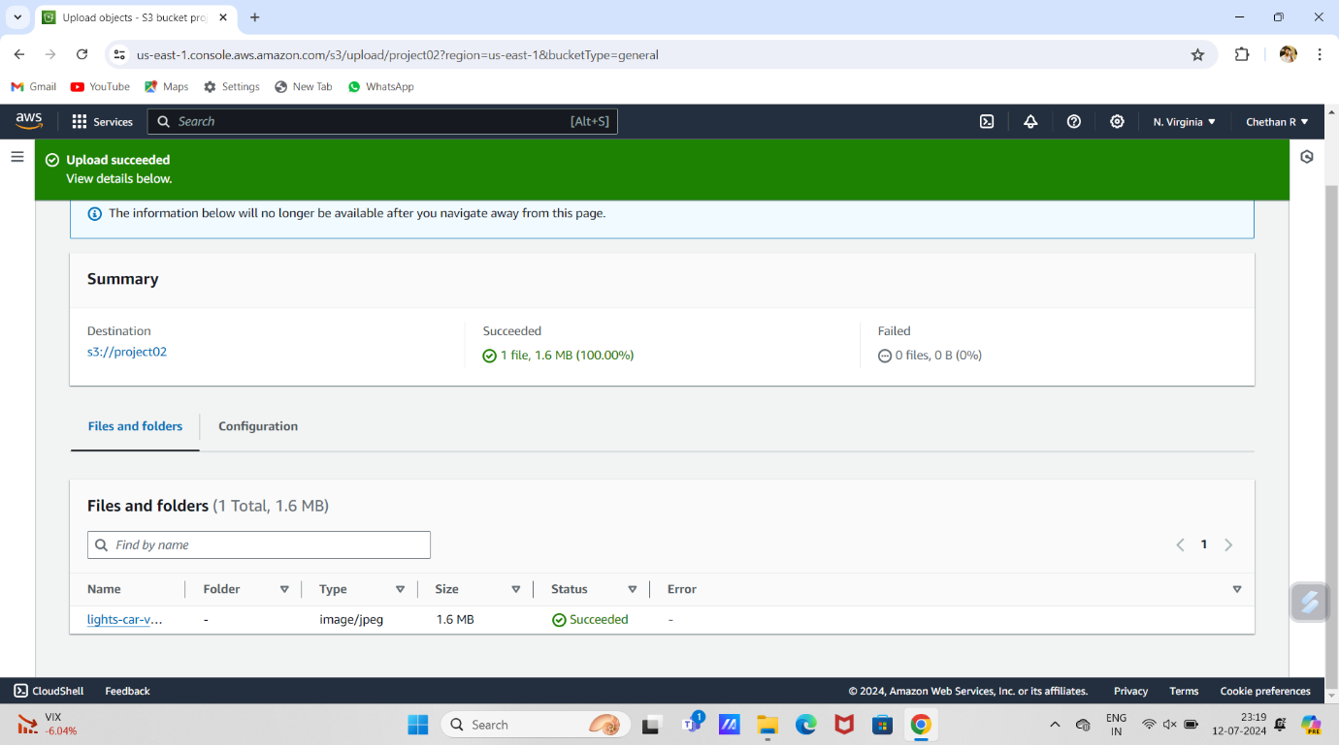

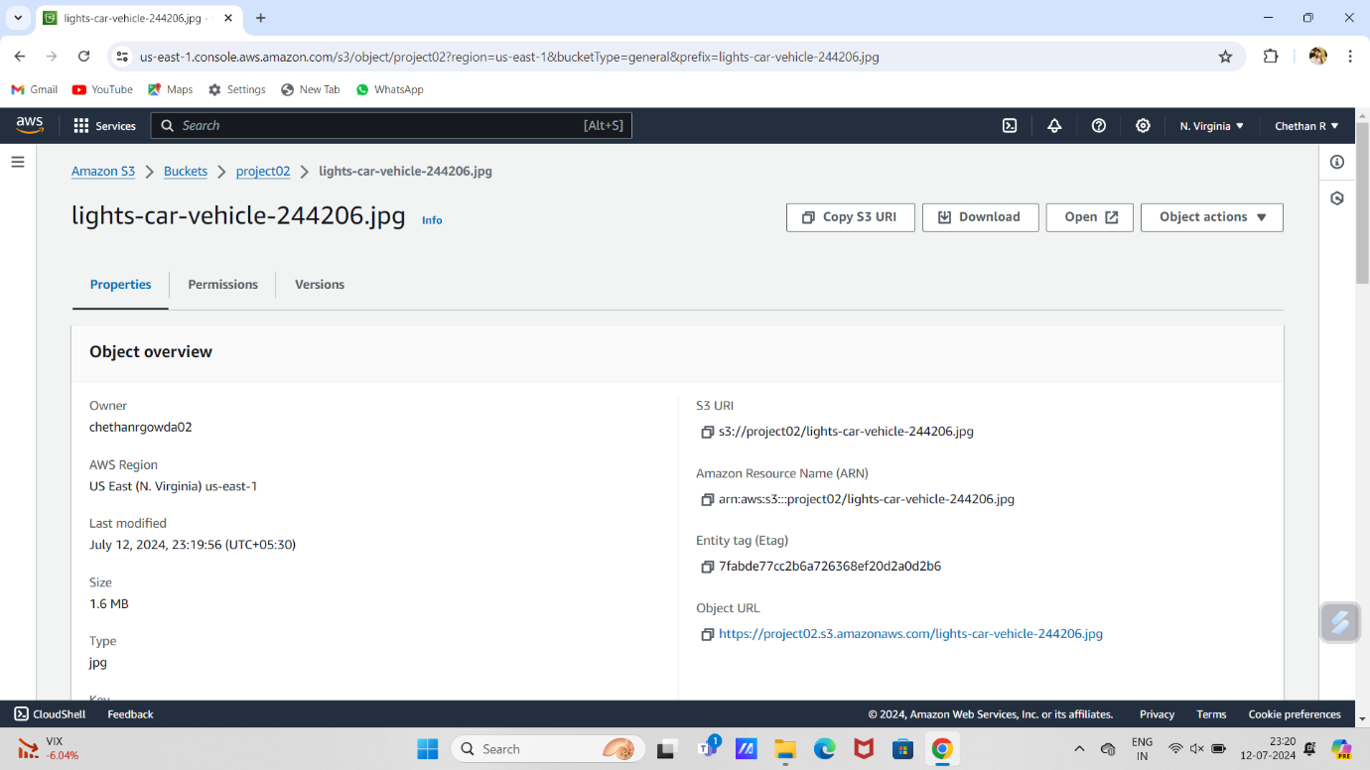

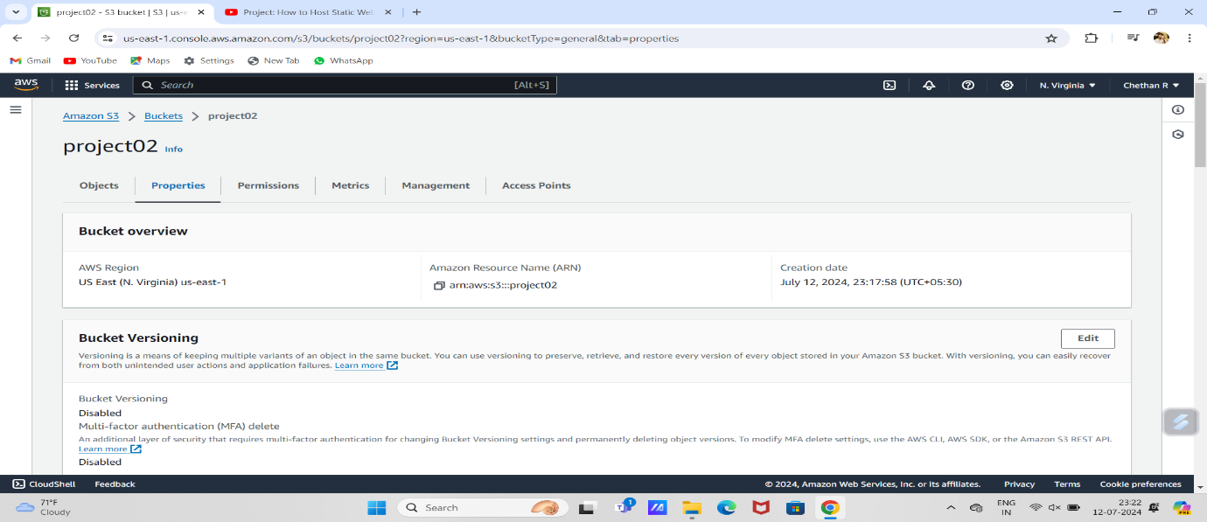

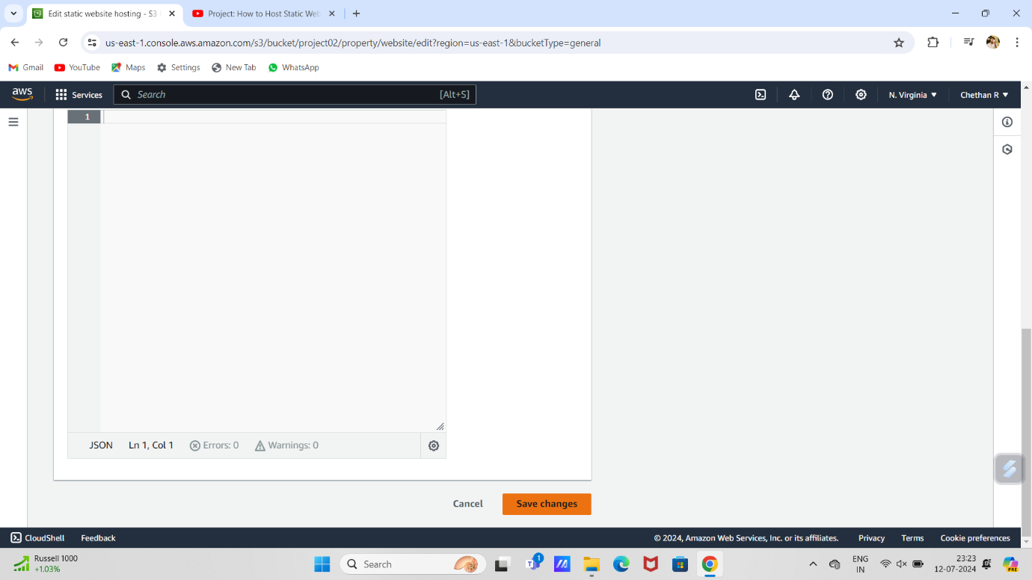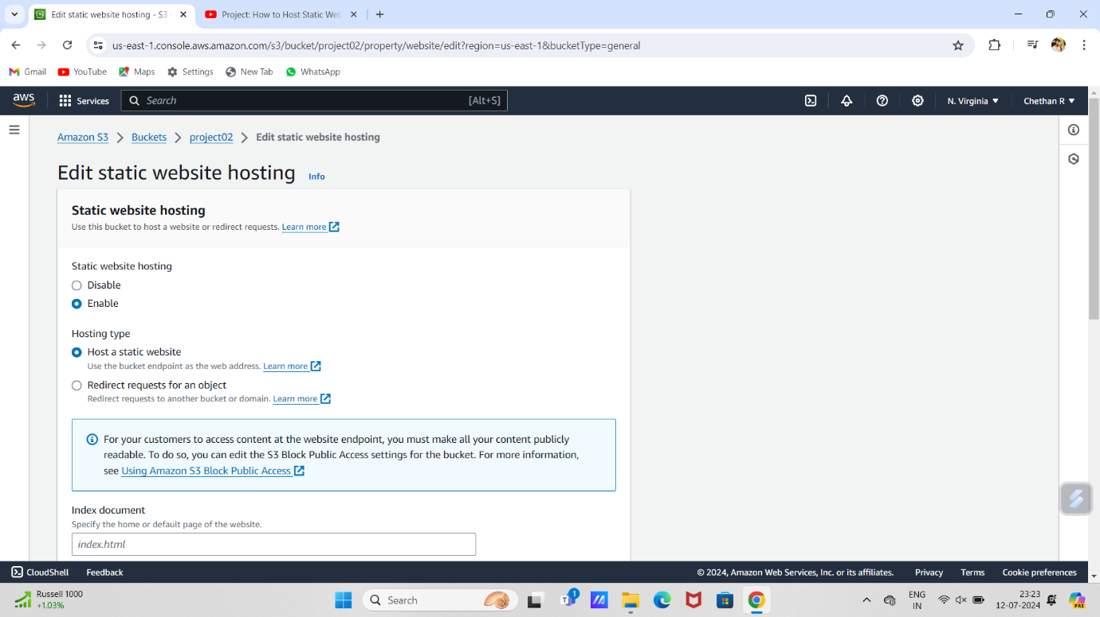

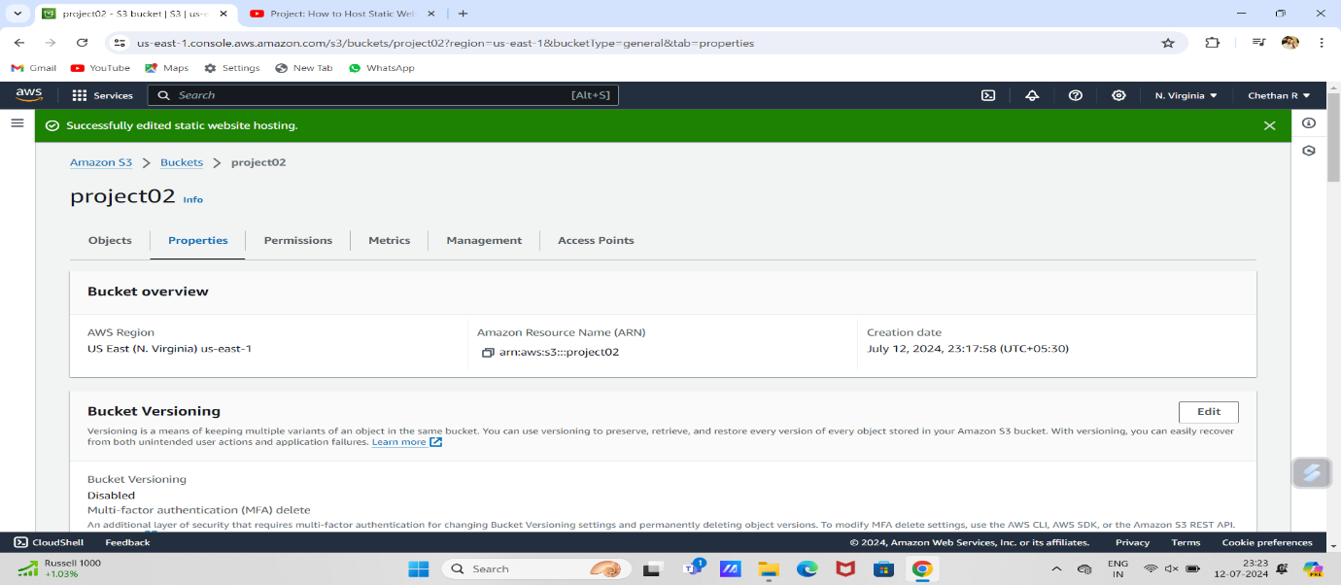

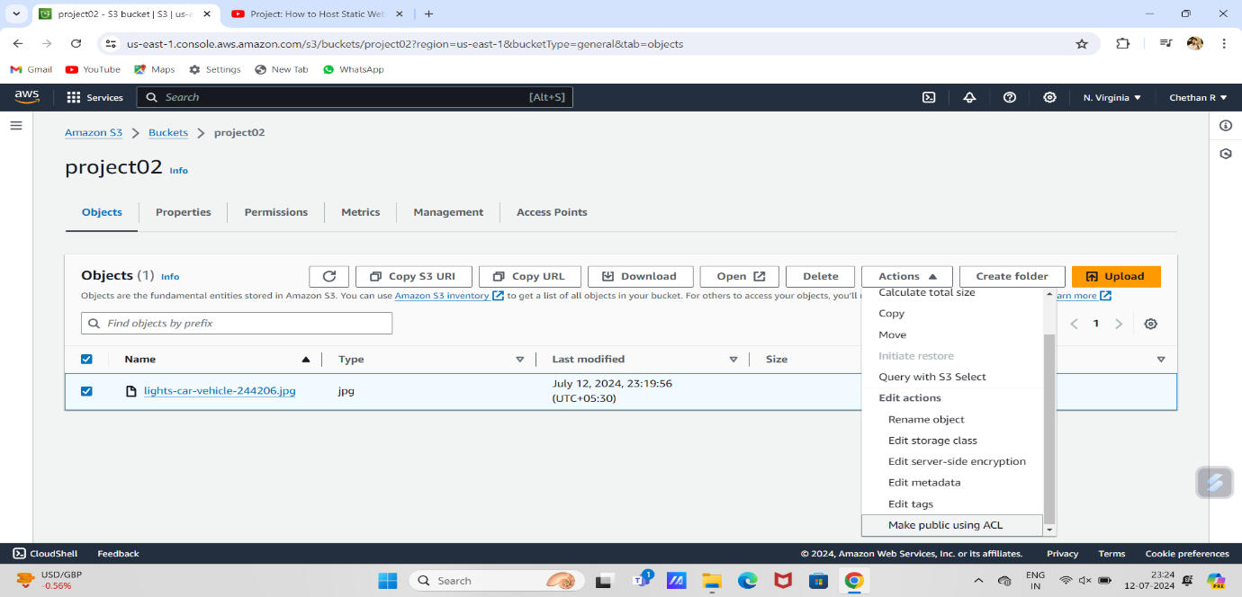

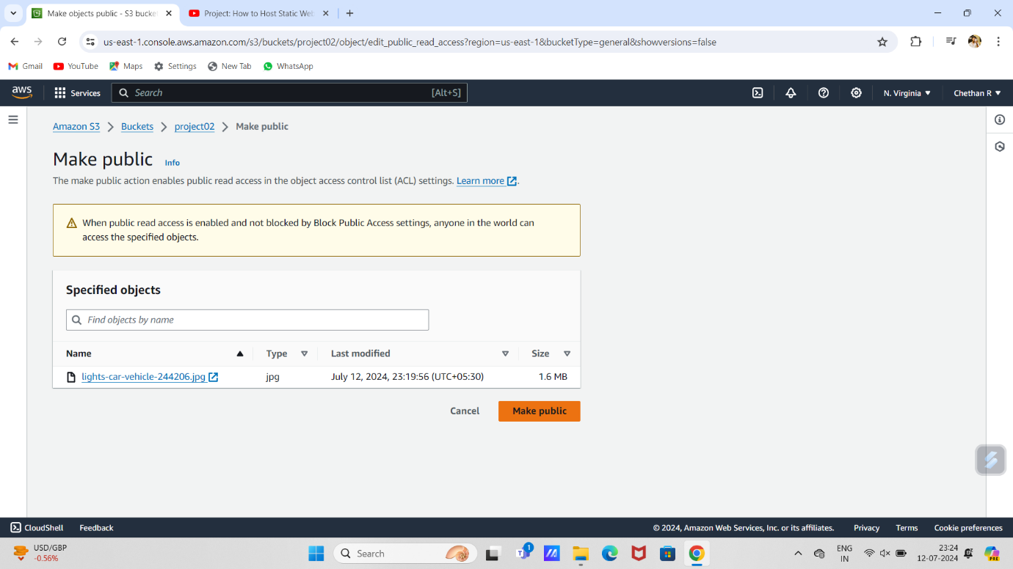

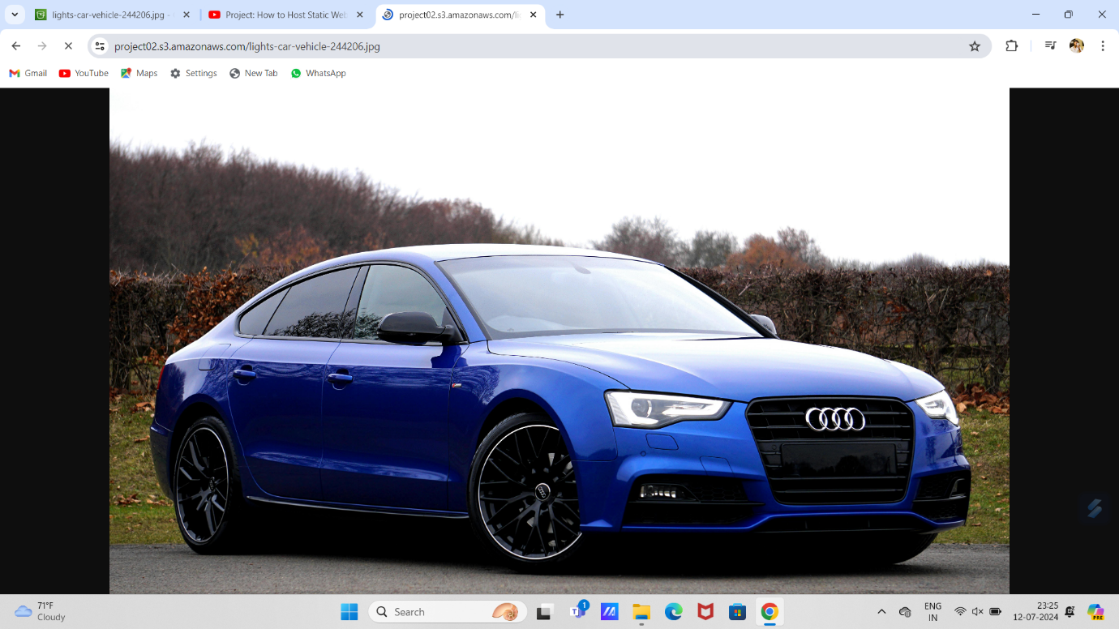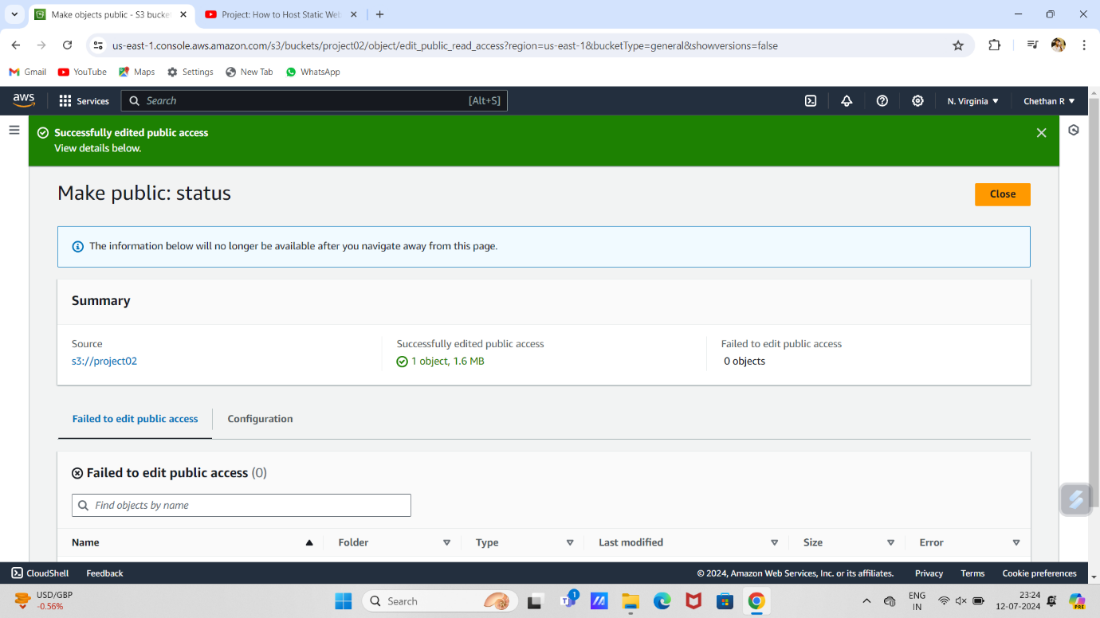

# SET UP RDS FOR DATABASE & CONNECTING WITH EC2 AND CREATING DATABASE

1.open aws account.

2.search for RDS and create database ,choose database standard create ,engine option my sql, give database name ,set master password ,enable storage autoscaling and leave others as default and create database.

3.next search for EC2 launch instance give a instance name and select ubuntu ,select free tier and leave others as default and launch the instance .

4.then go for the instance id and select security and select security group there edit inbound and out bound rules port range is 3366 and source anywhere in both inbound and outbound and save.

5.open EC2 open our project and open instance id , there go for the security and copy security id .

5.open RDS databases and our database go for vpc security group select security id and edit inbound rule and add rule and paste that in the custom and save rule

6. then open CMD

7. 1.Cd Downloads 2.ssh -i (key name) ubuntu@(public ip address in ec2 instance) 3.yes 4.sudo apt update 5.sudo apt install mysql-client -y 6.mysql -h (paste the endpoint in rds d

atabase) -u admin -p 7.enter the password 8.select * from (table name); 9.exit 10.exit 11.exit

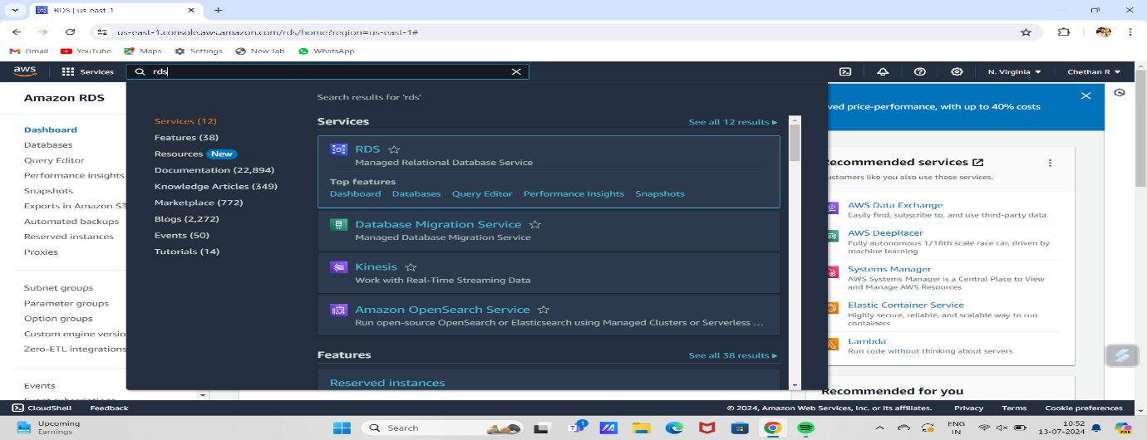

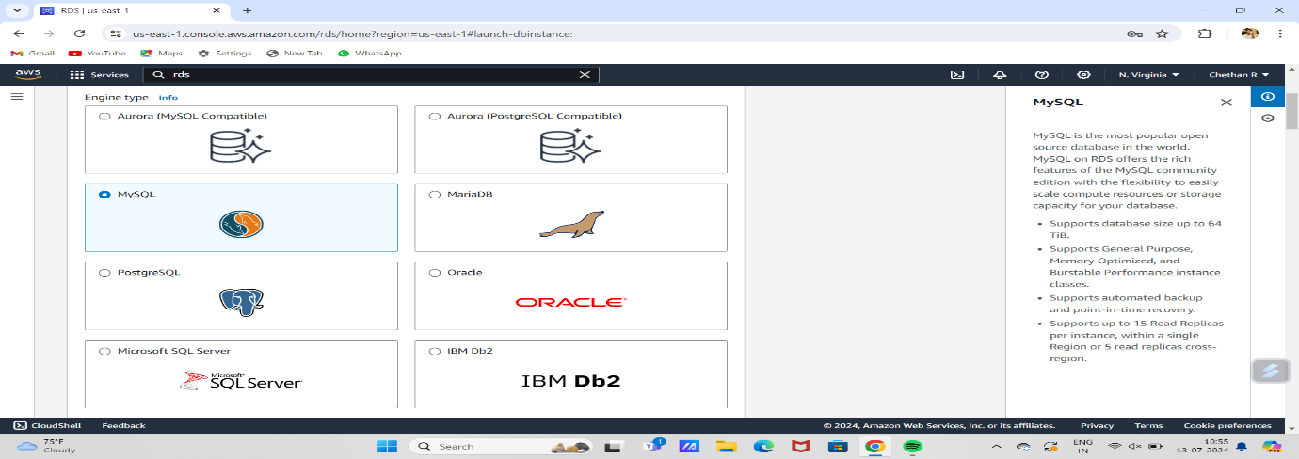

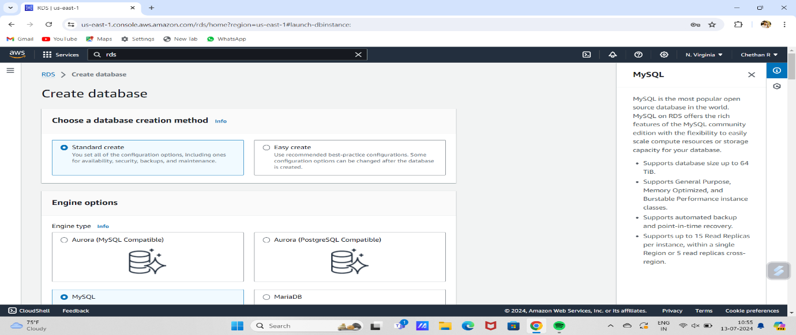

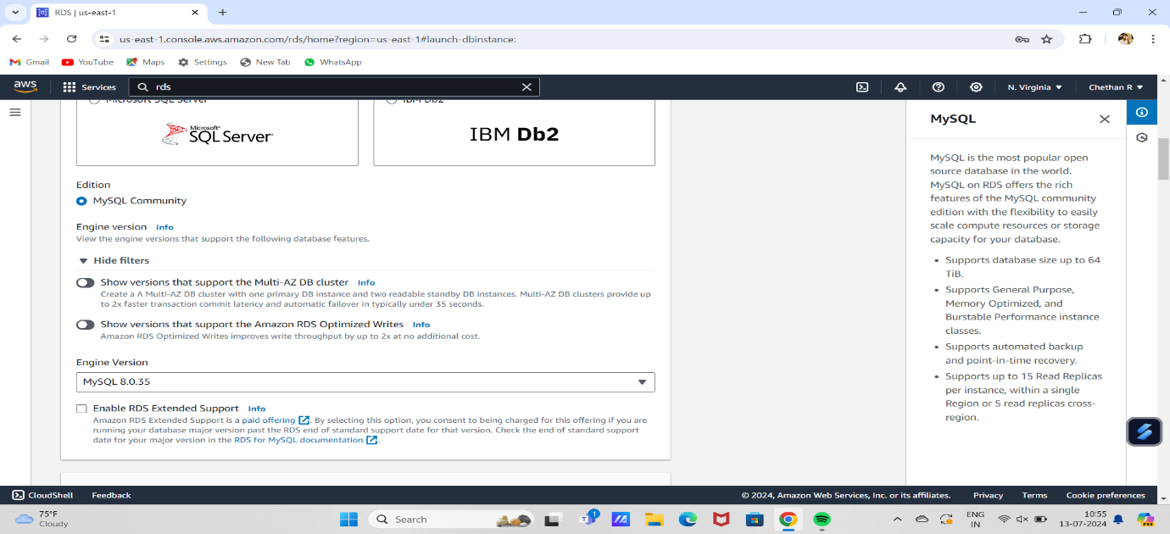

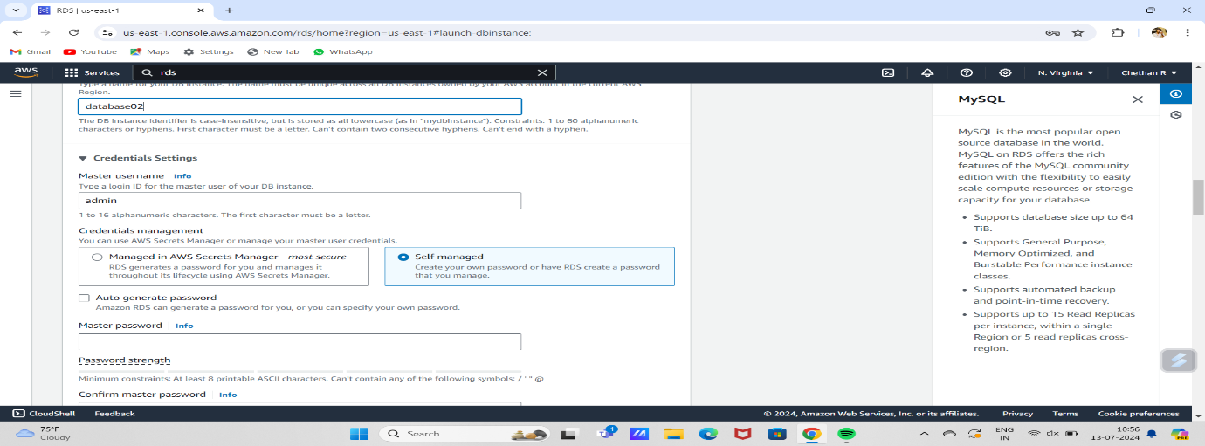

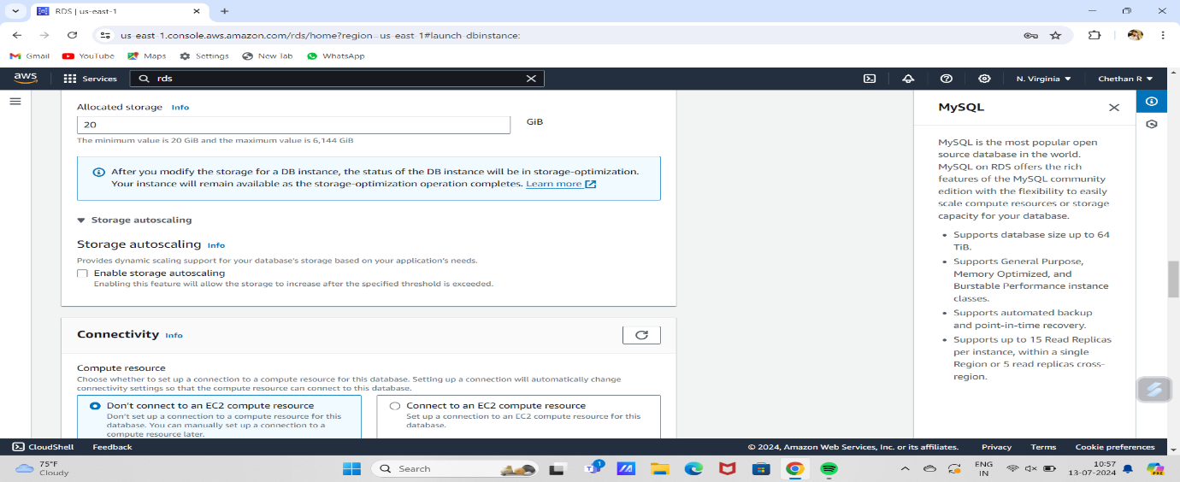

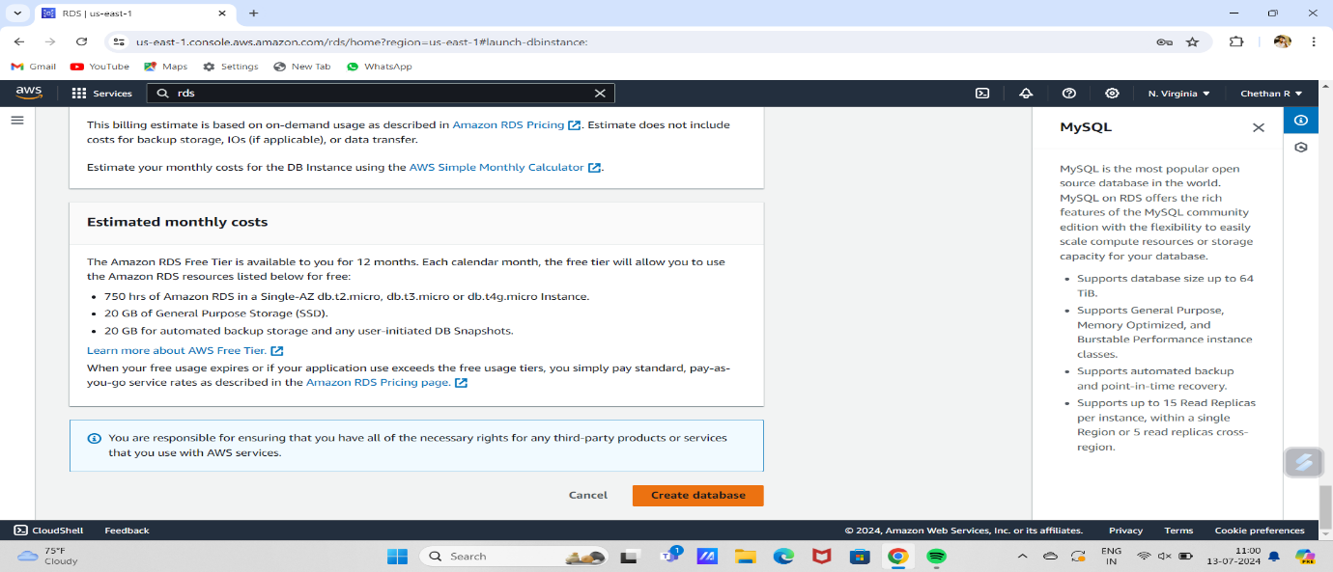

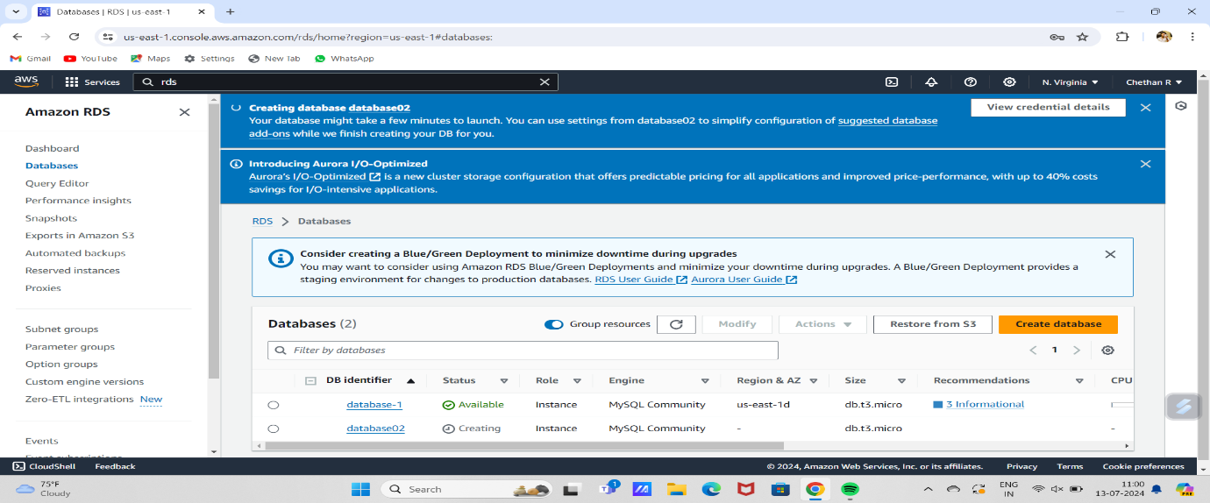

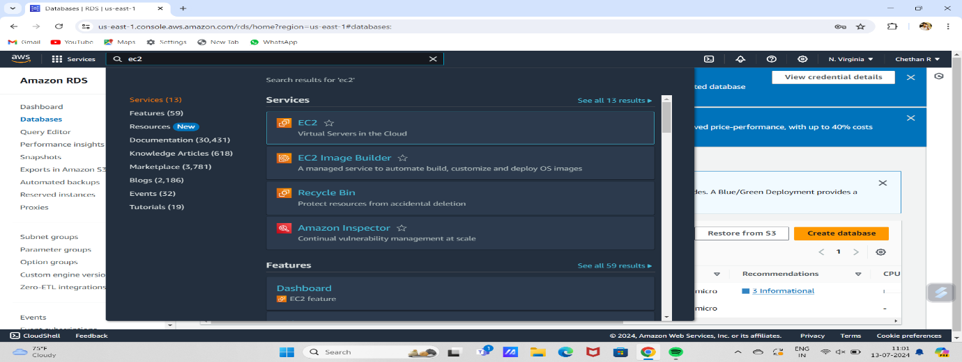

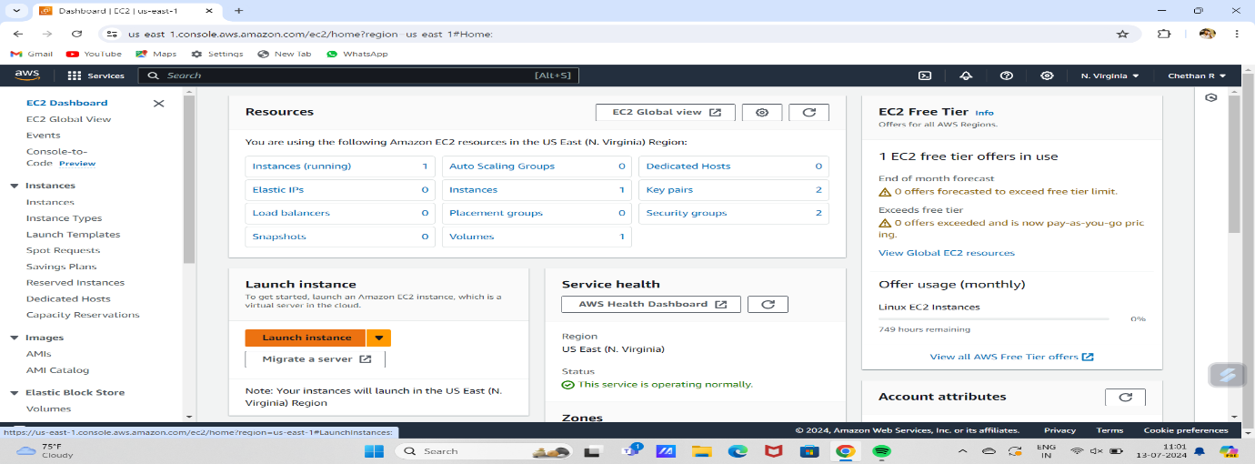

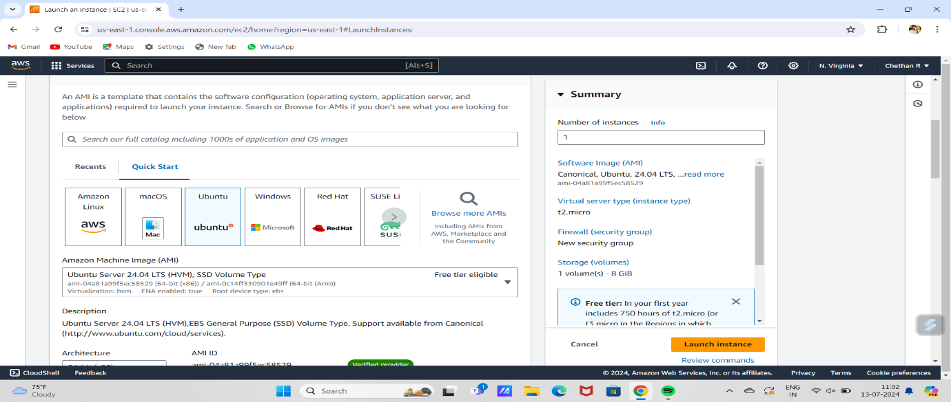

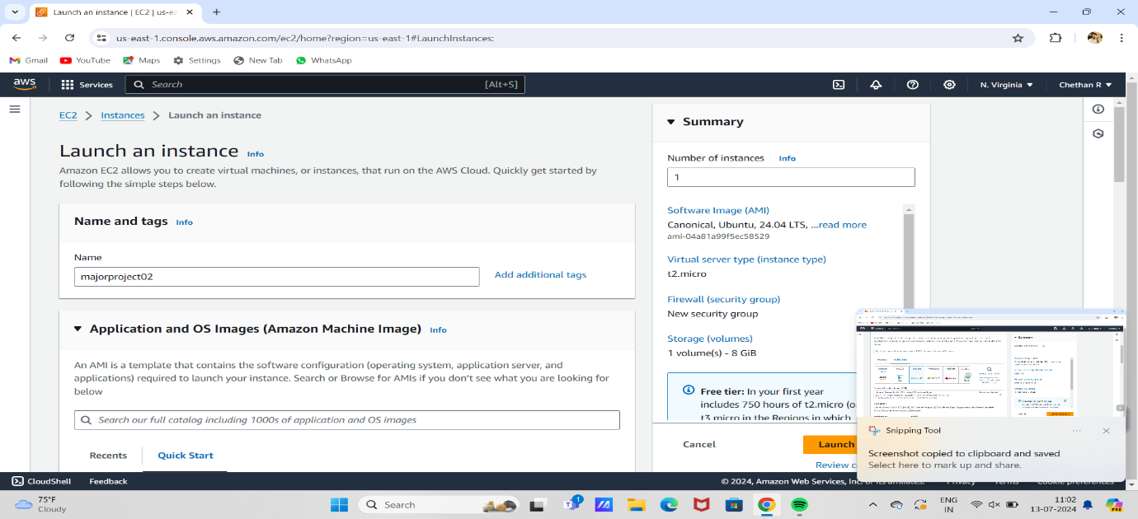

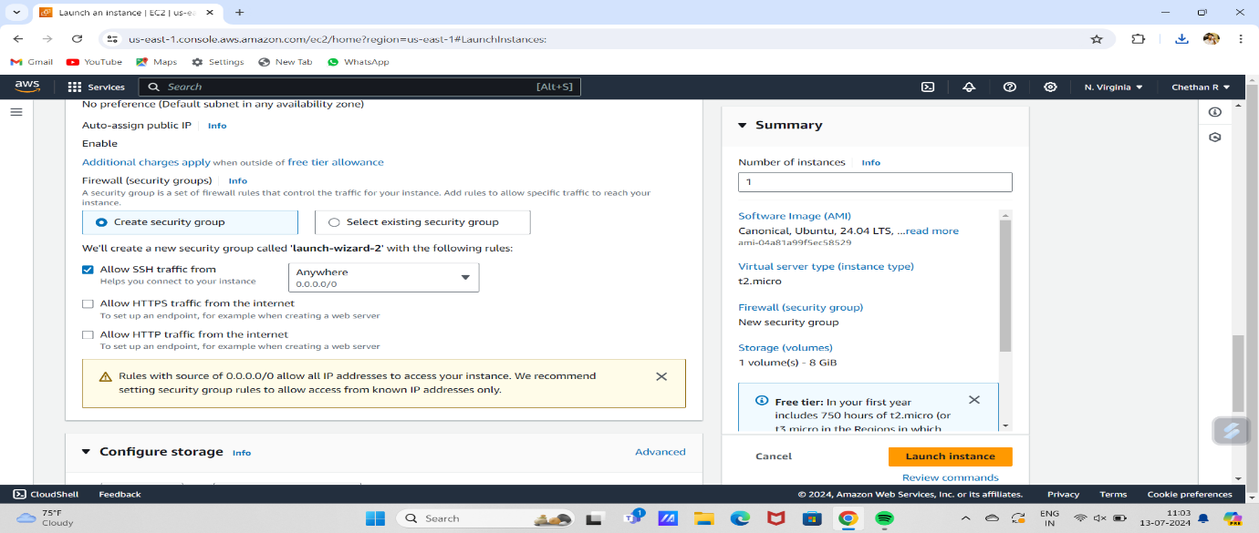

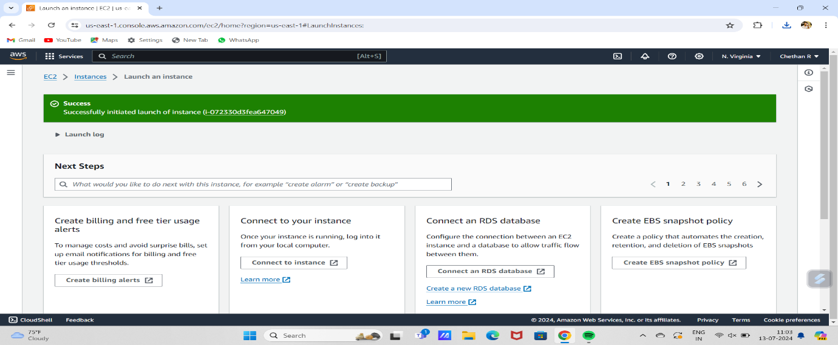

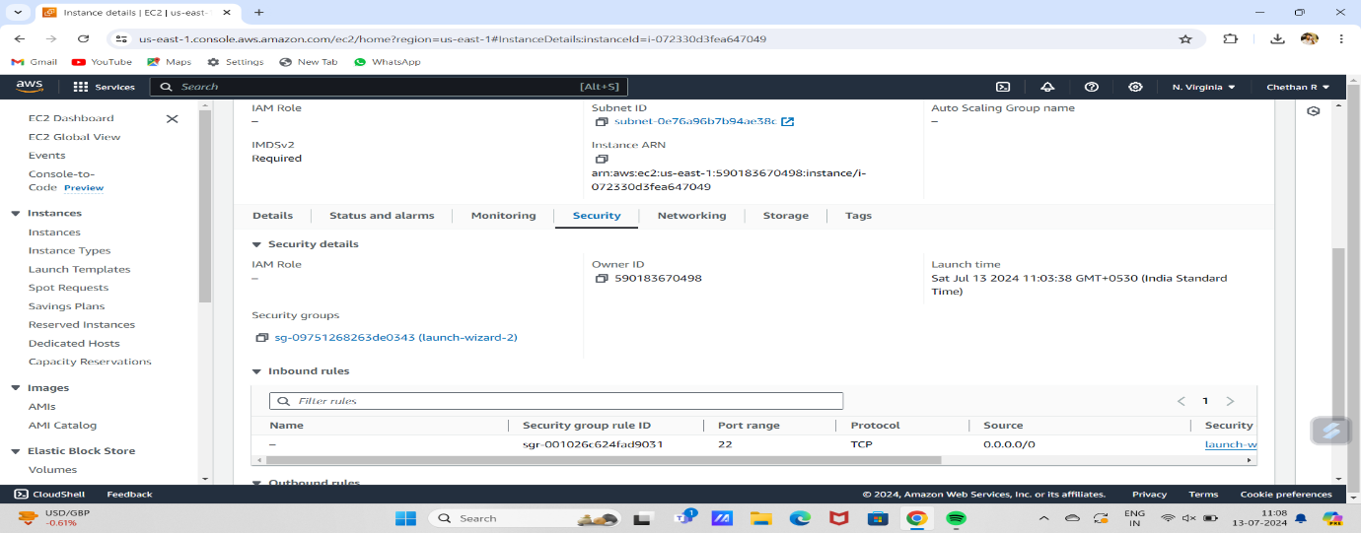

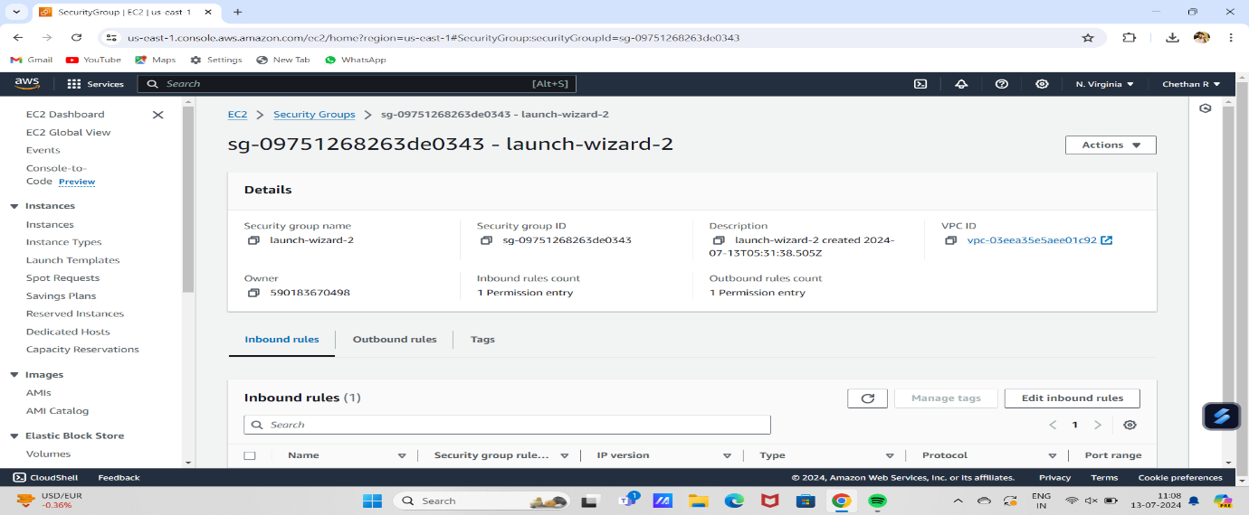

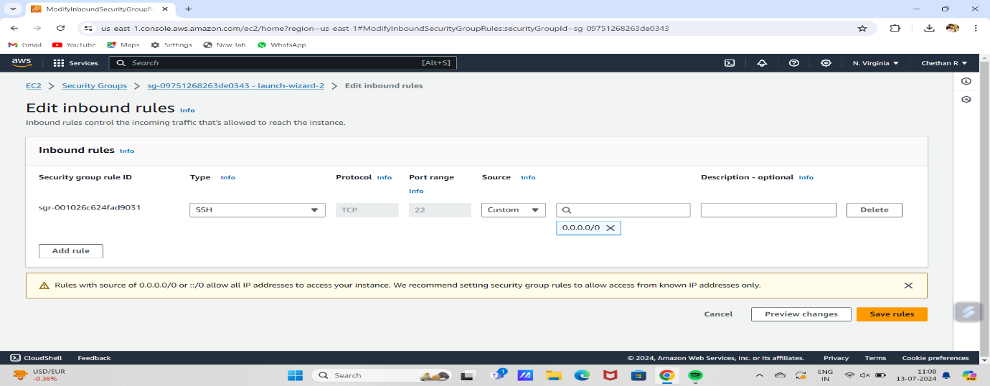

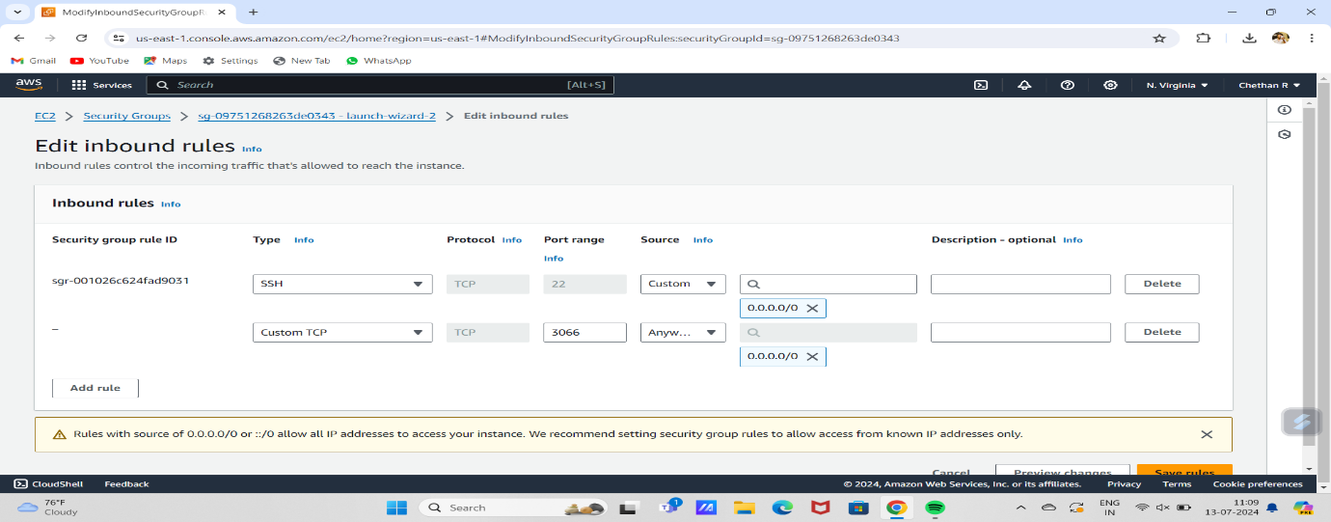

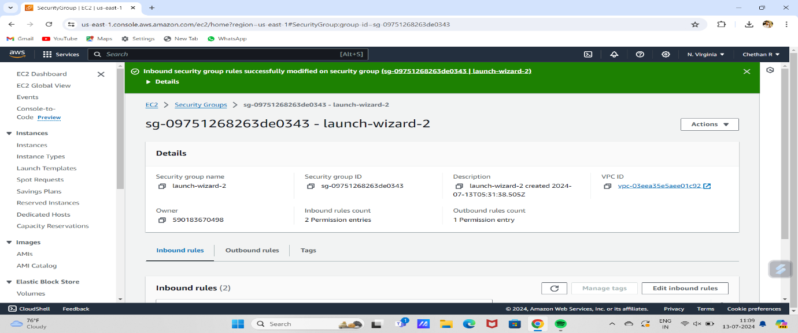

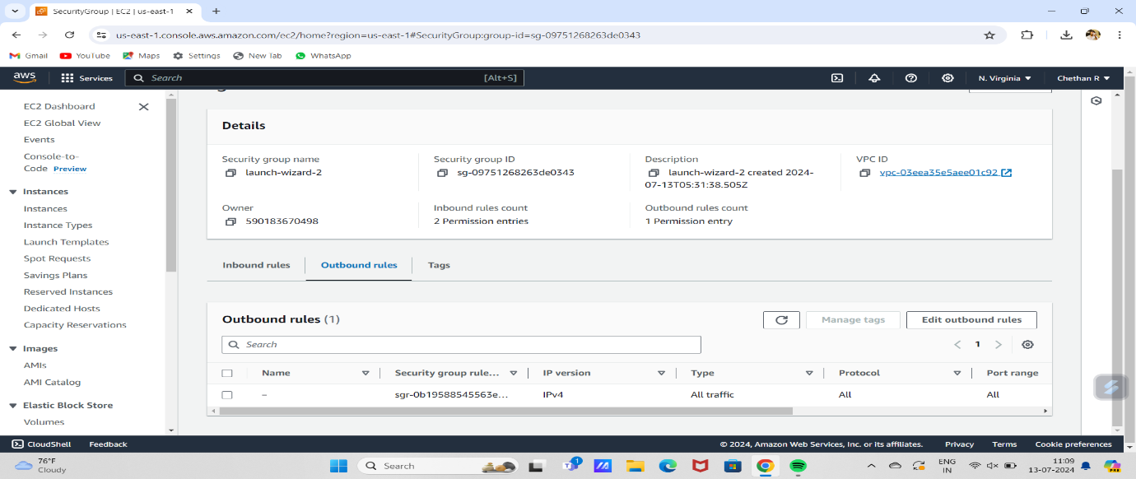

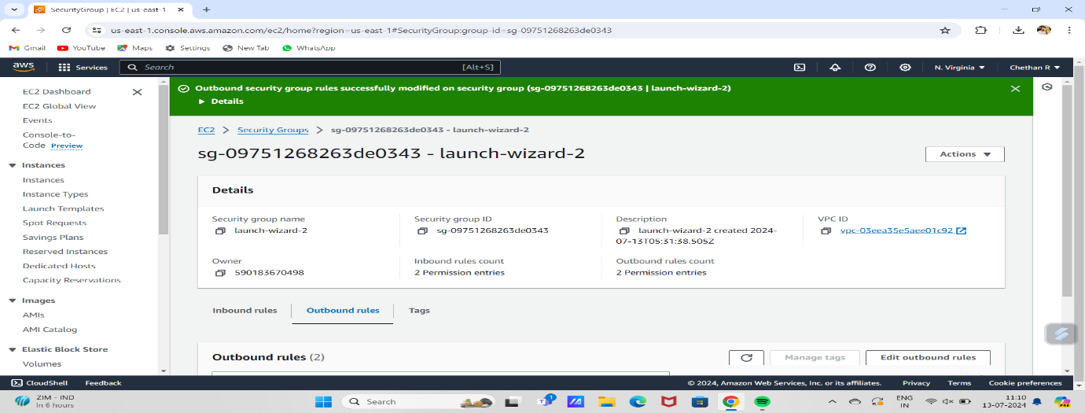

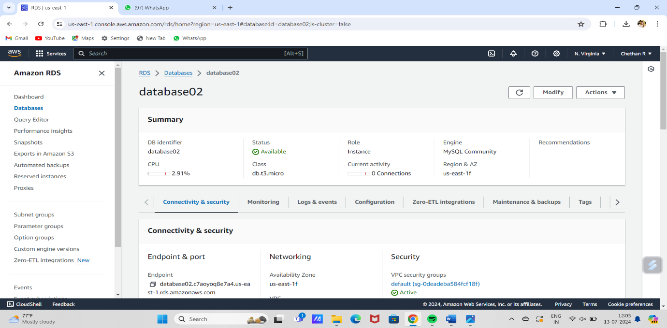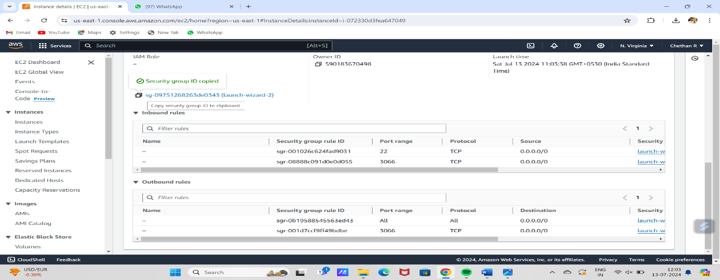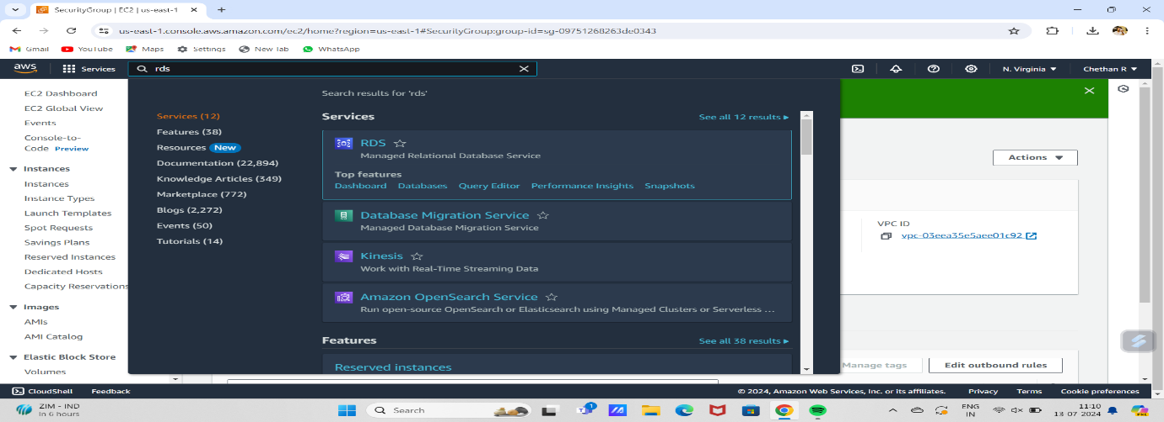

# 

# 

# 

# 

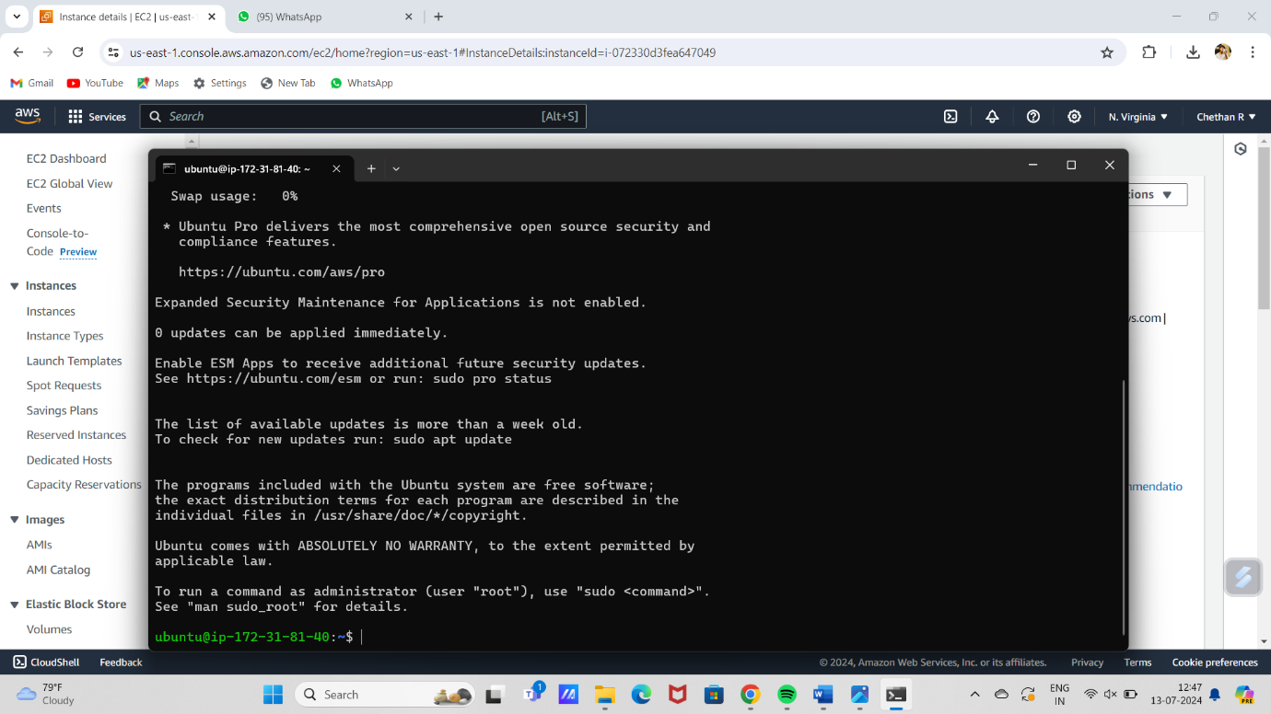

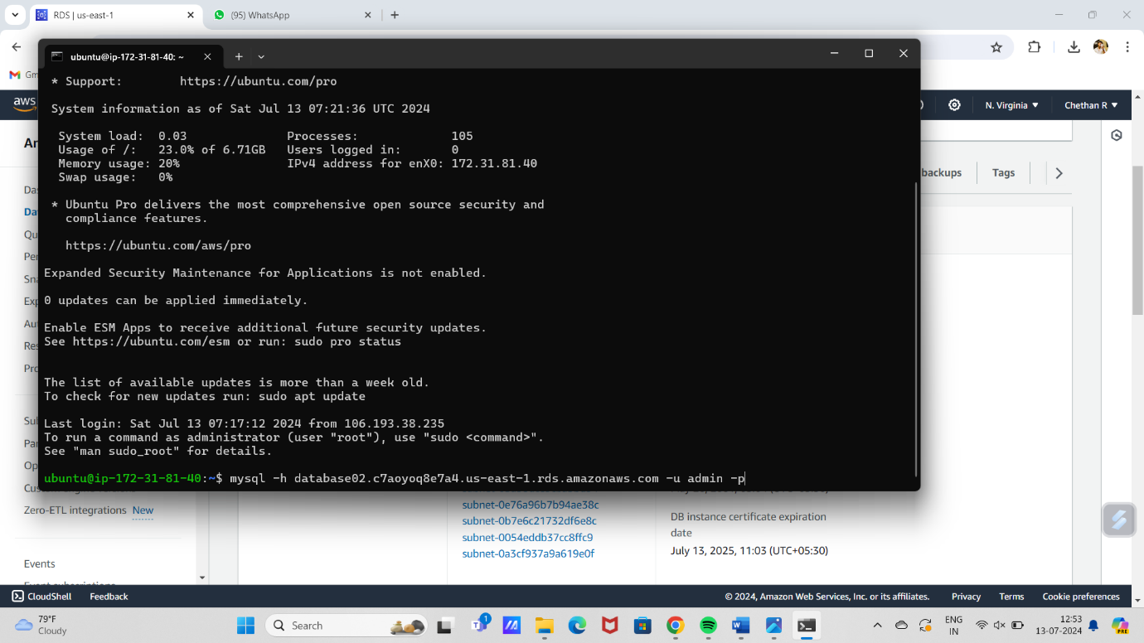

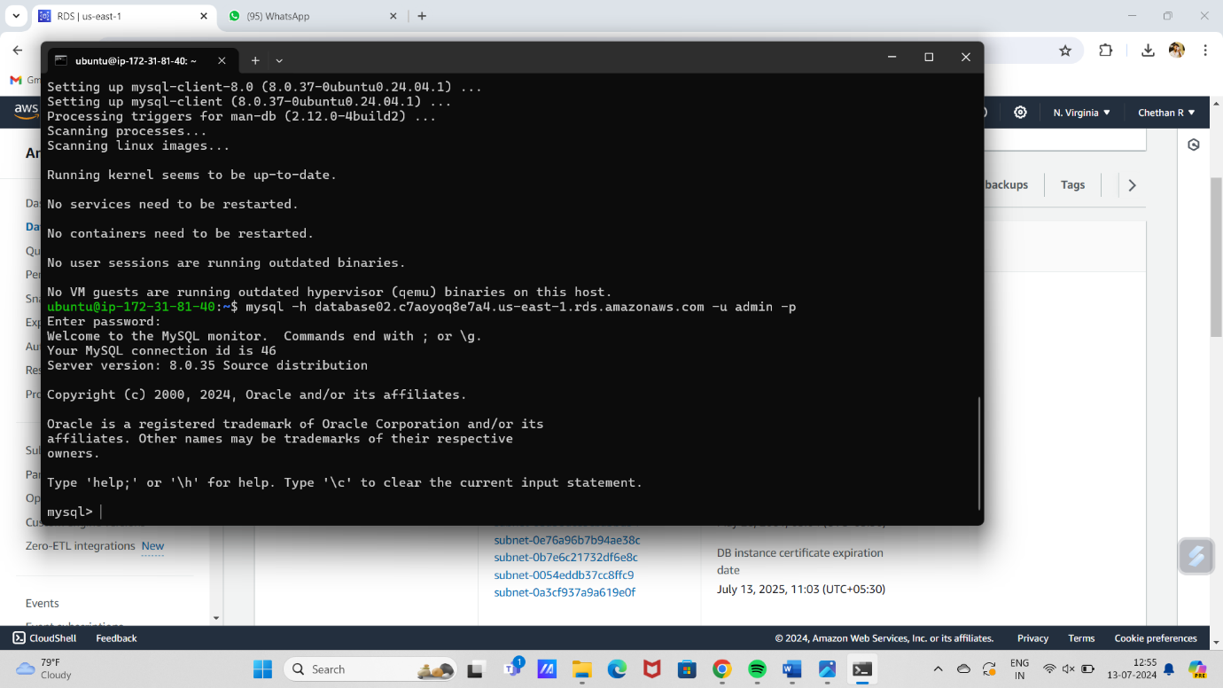

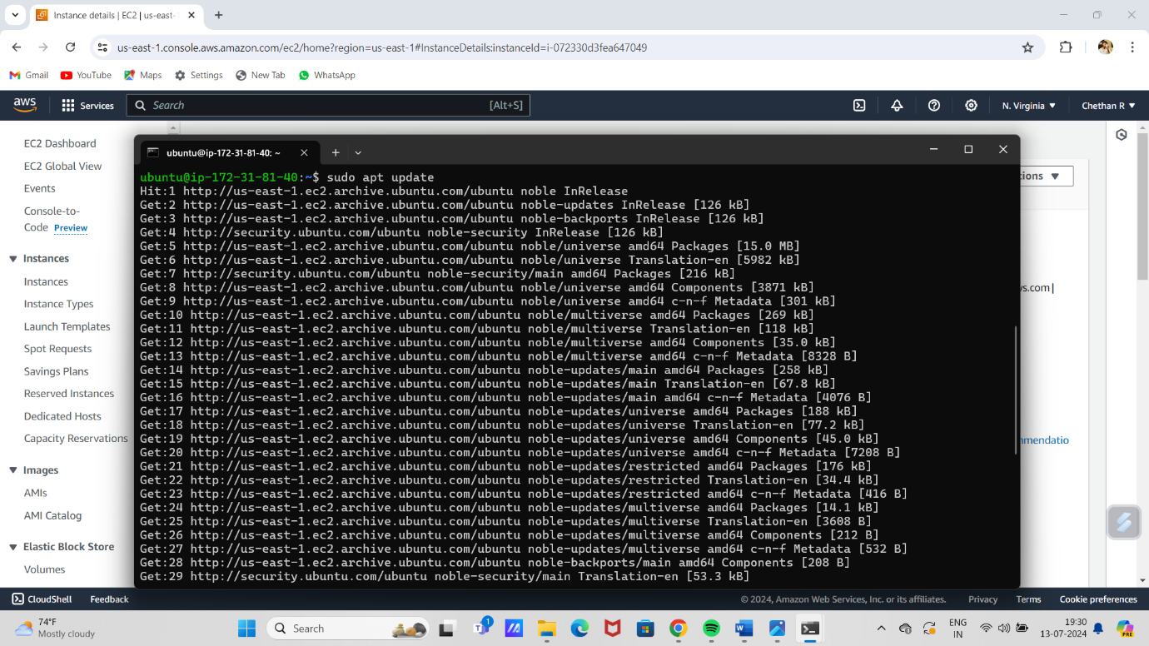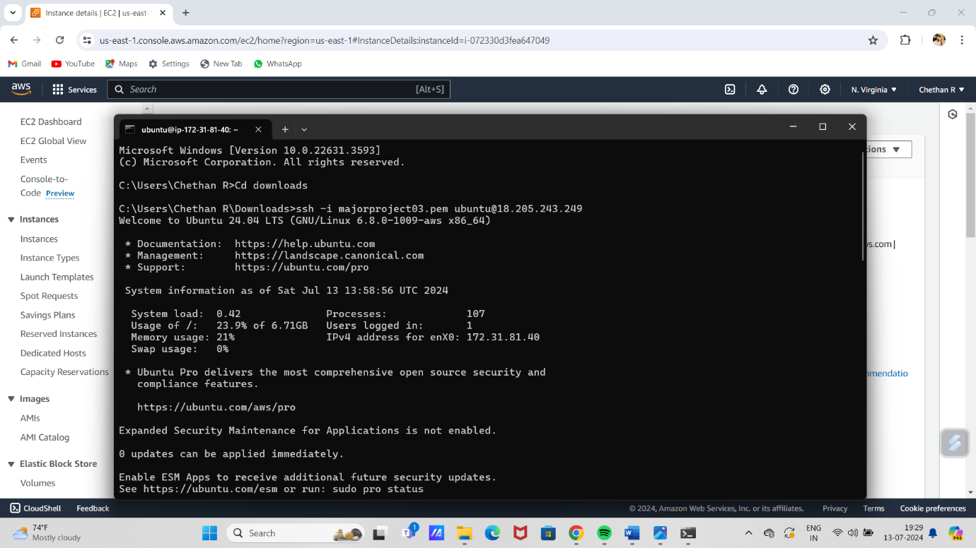

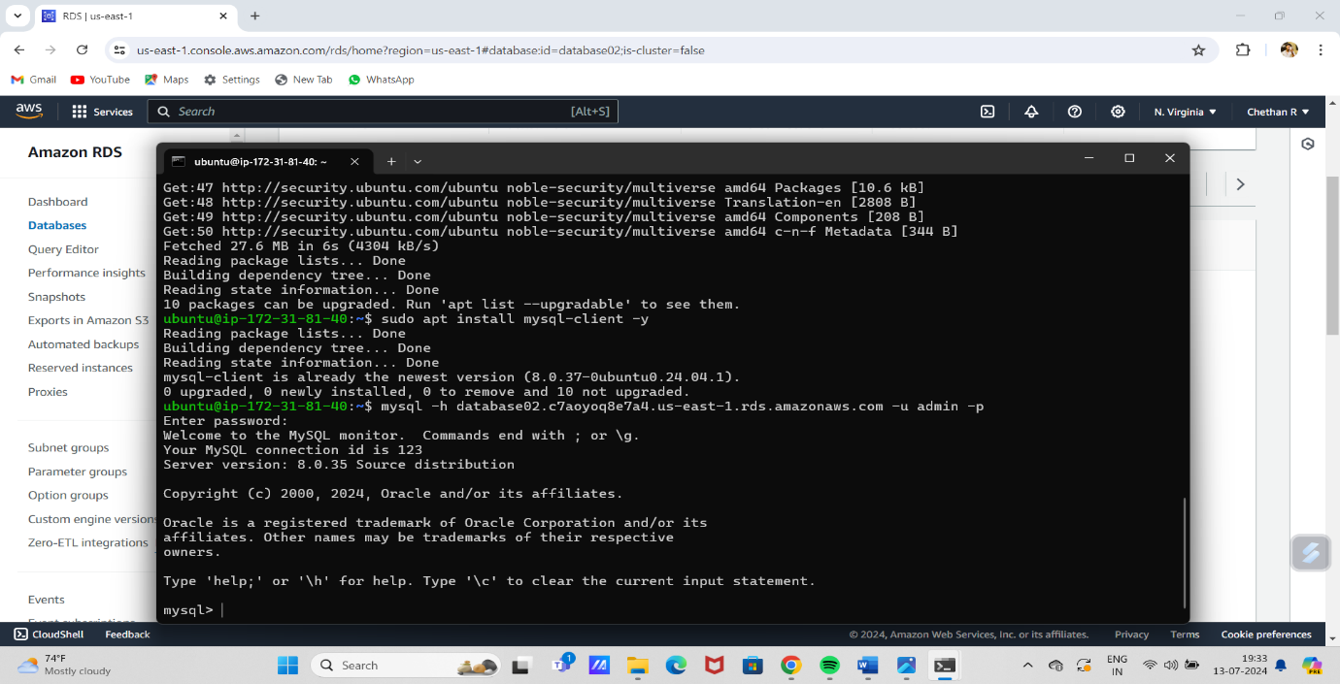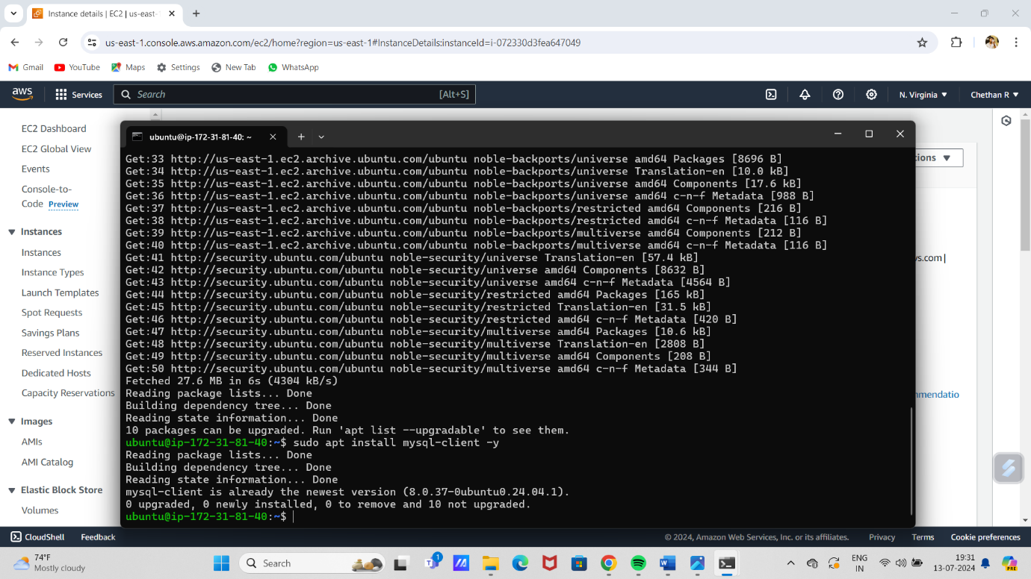

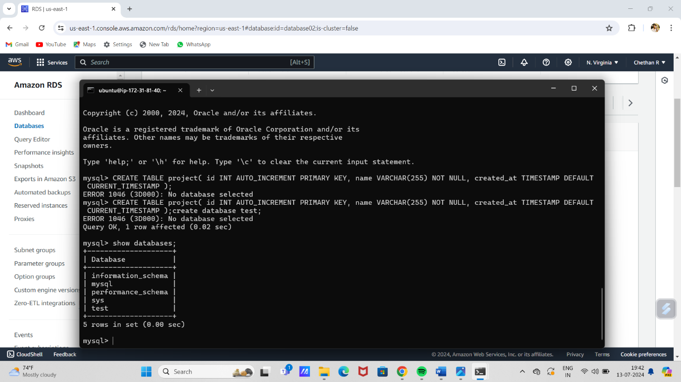

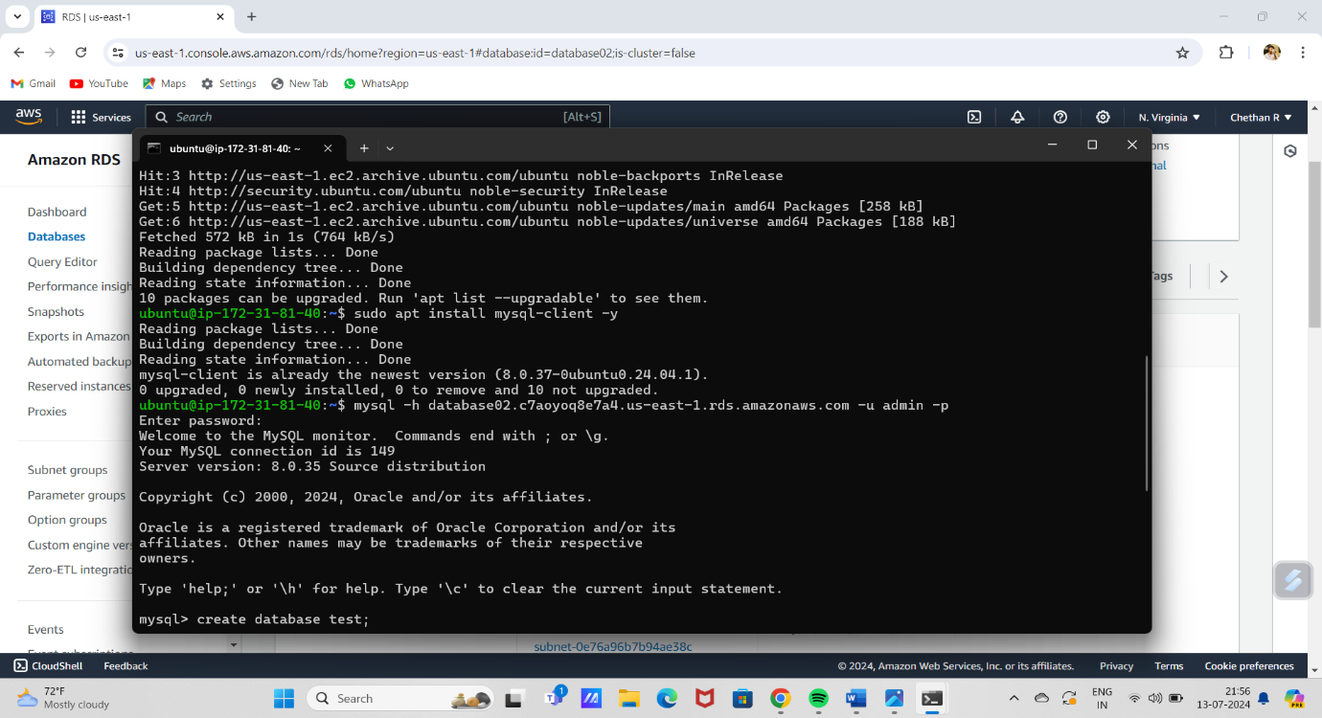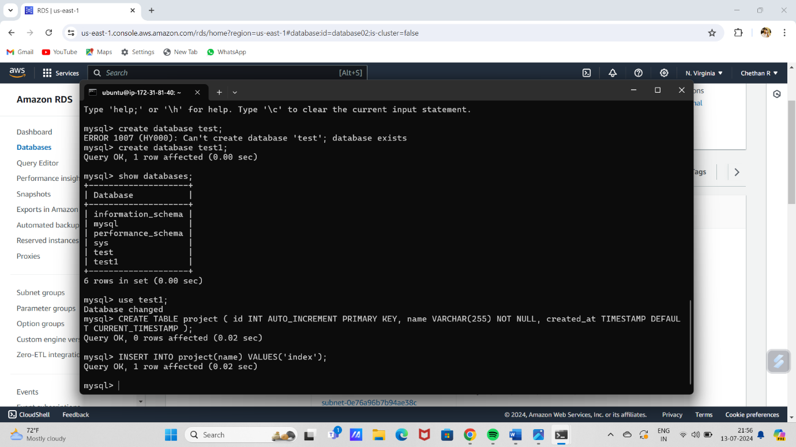

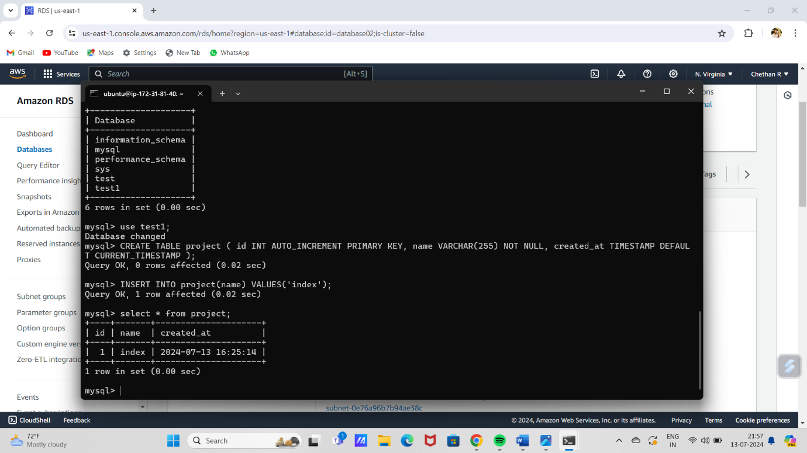

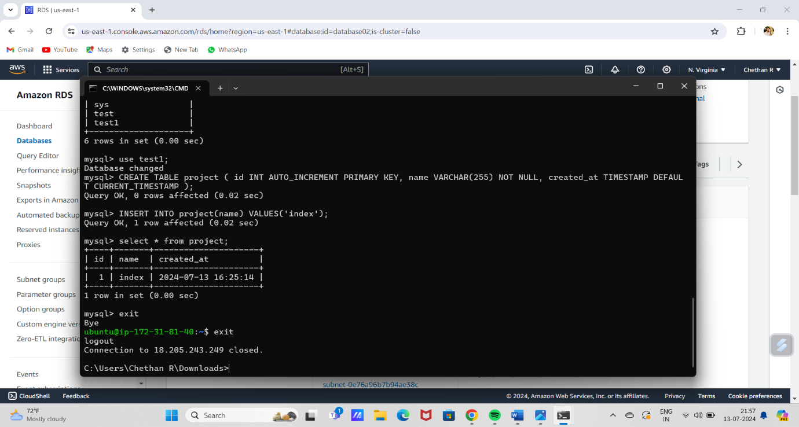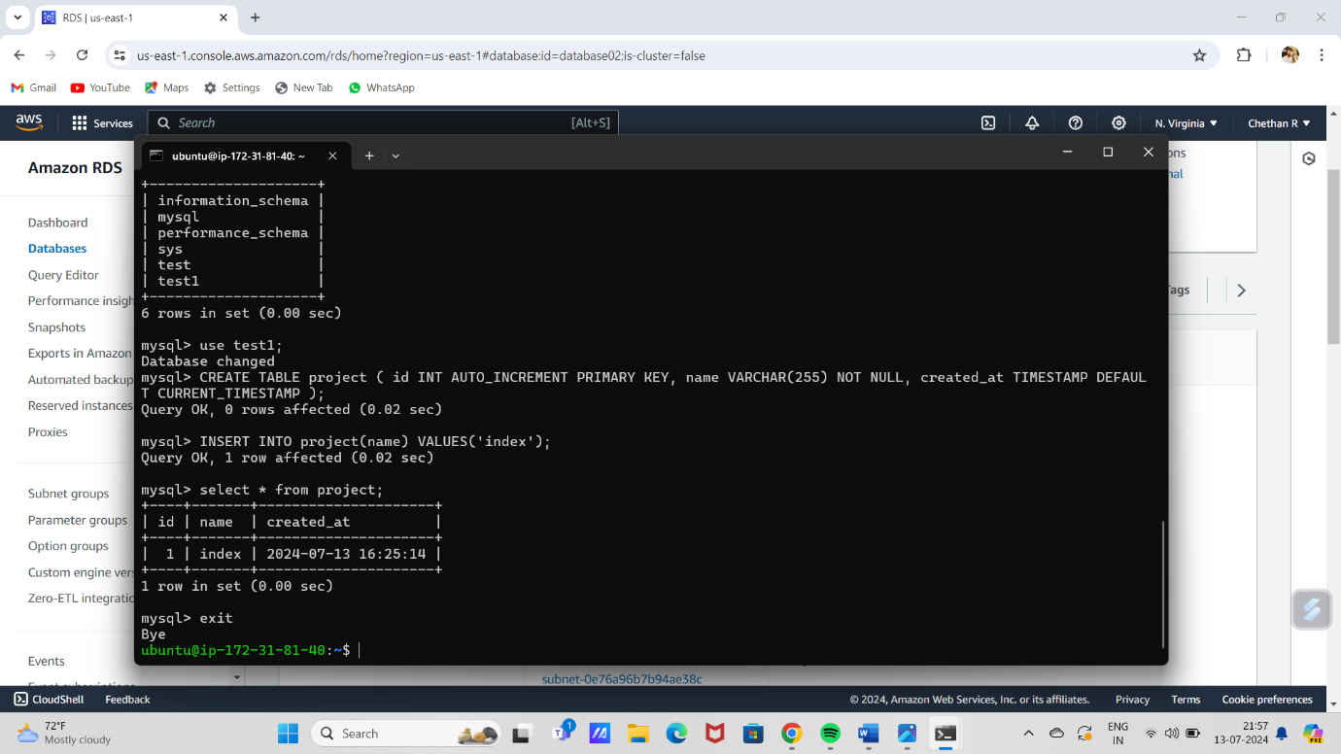

# LOAD BALANCER

1.open aws account.

2. open ec2 and create 2 instances, while creating give a instance names , select key pairs and leave others as default.

3.next go for the target group and create target group by providing the name and set protocol to HTTP with port 80,set health check path to /index.html by creating a file, and select both instances and click including targets and set port as 80 and click create group, and check the health status have 5 sec timeout.

4. open load balancer click load balancer ,choose the name of load balancer ,set scheme and ip address type to internet-facing and ipv4, set network mapping to default vpc and add all availability zones, select security group if not there create security group with HTTP protocol and add listener with target group created. And check the summary, and create the load balancer ,and view the load balancer

5.then copy the application load balancer DNS id and paste it in the browser

6.note that the instance loaded first is random and it will change after 200 second after refreshing.

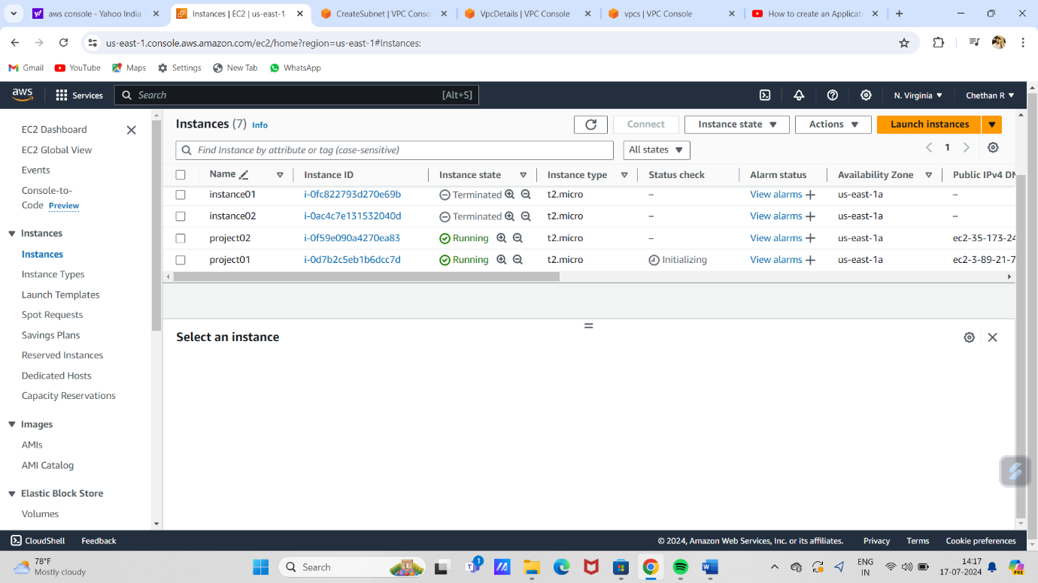

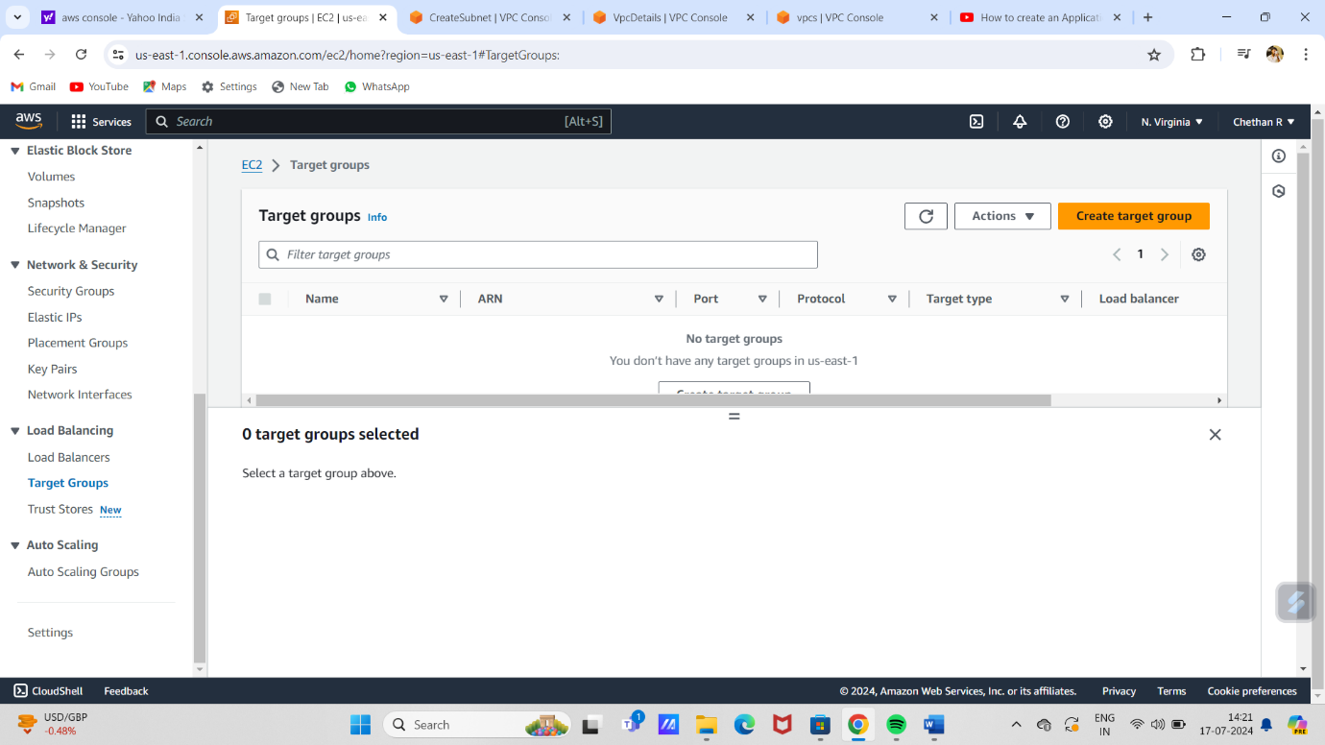

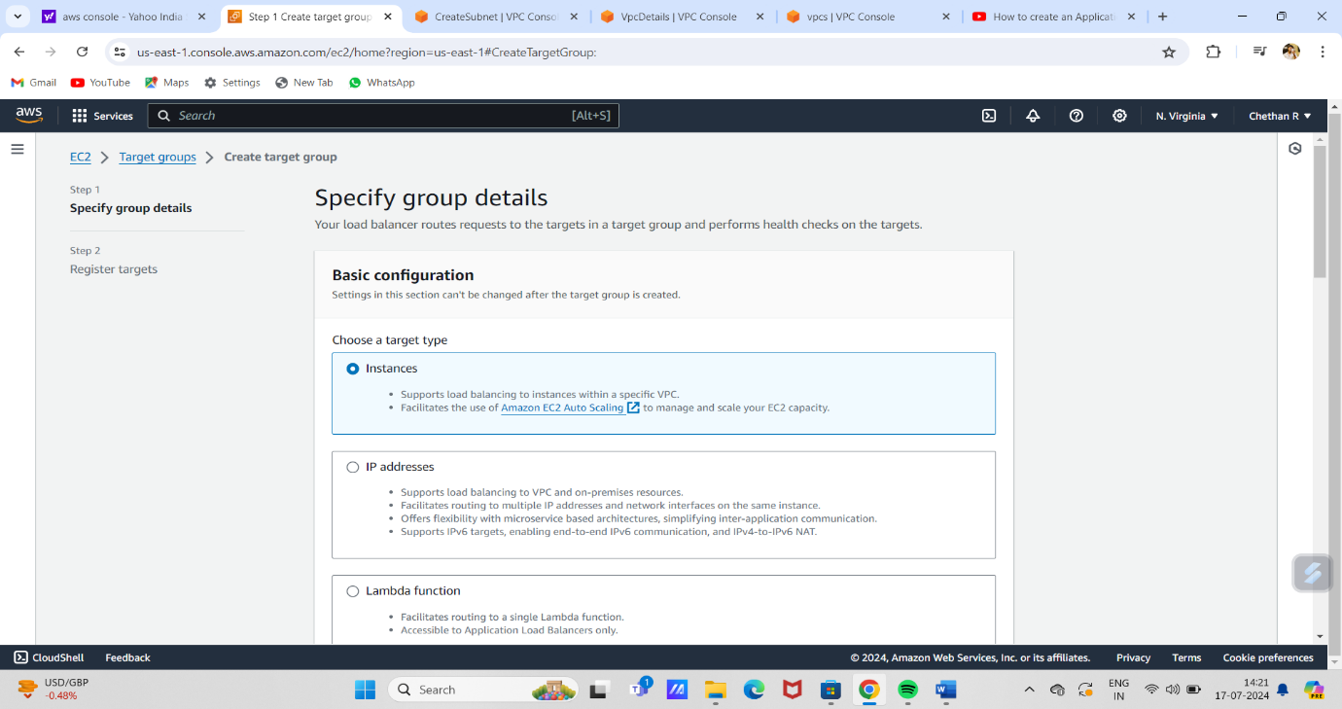

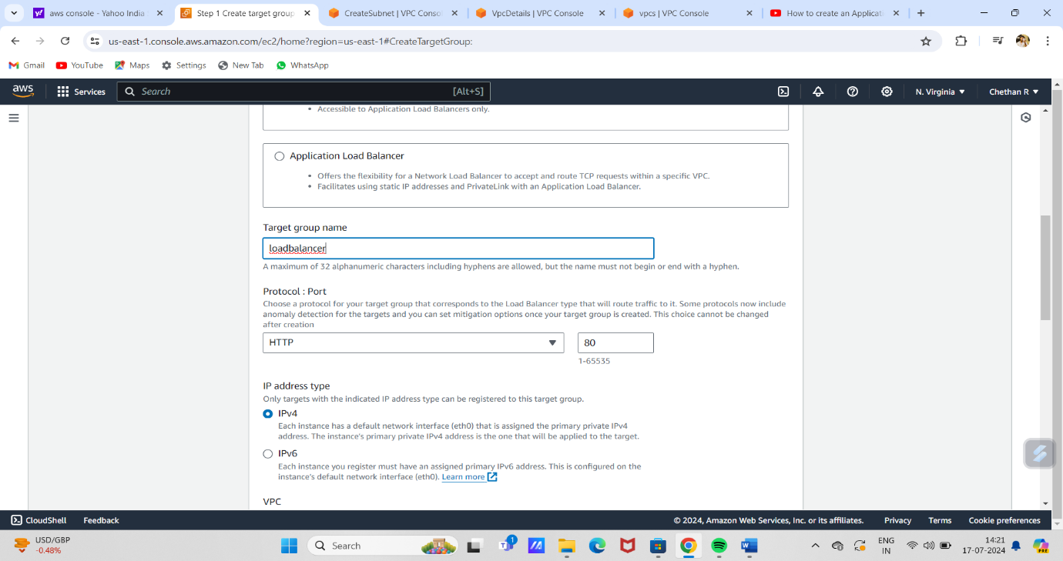

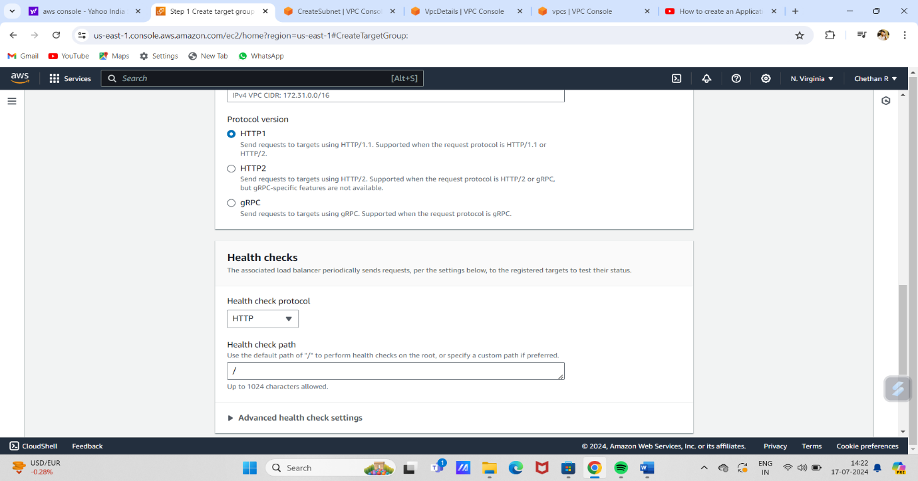

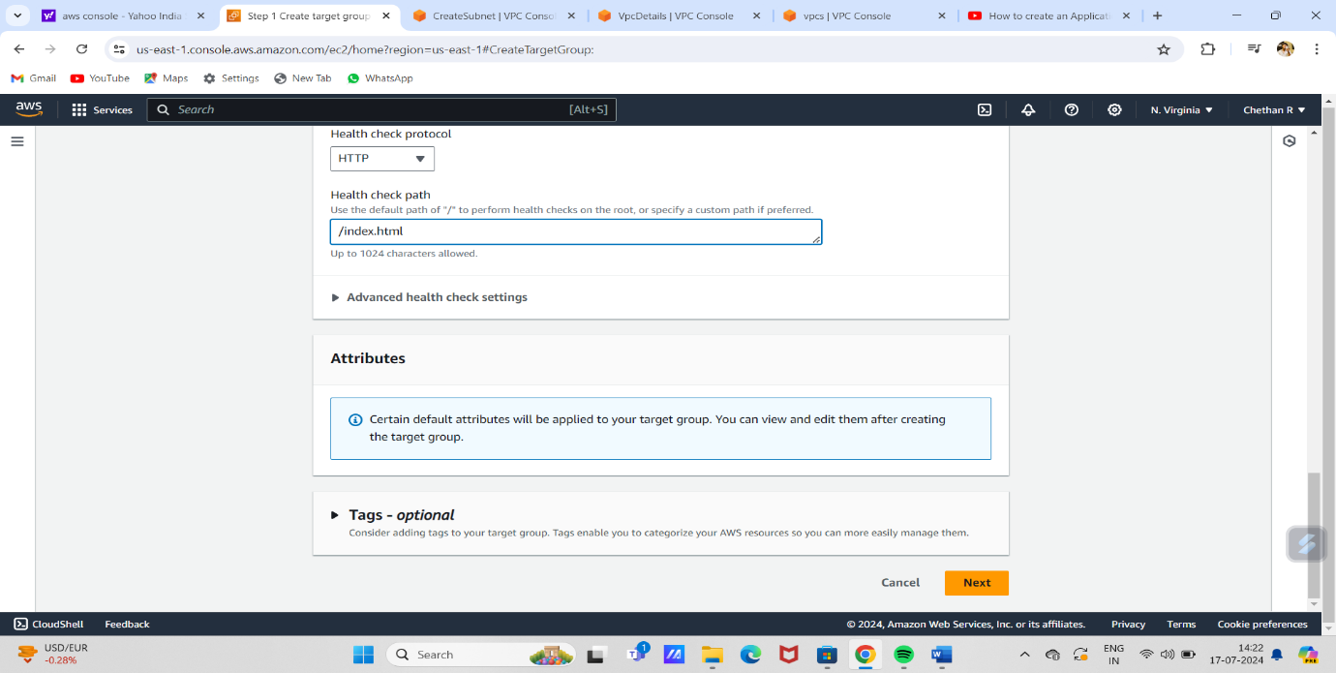

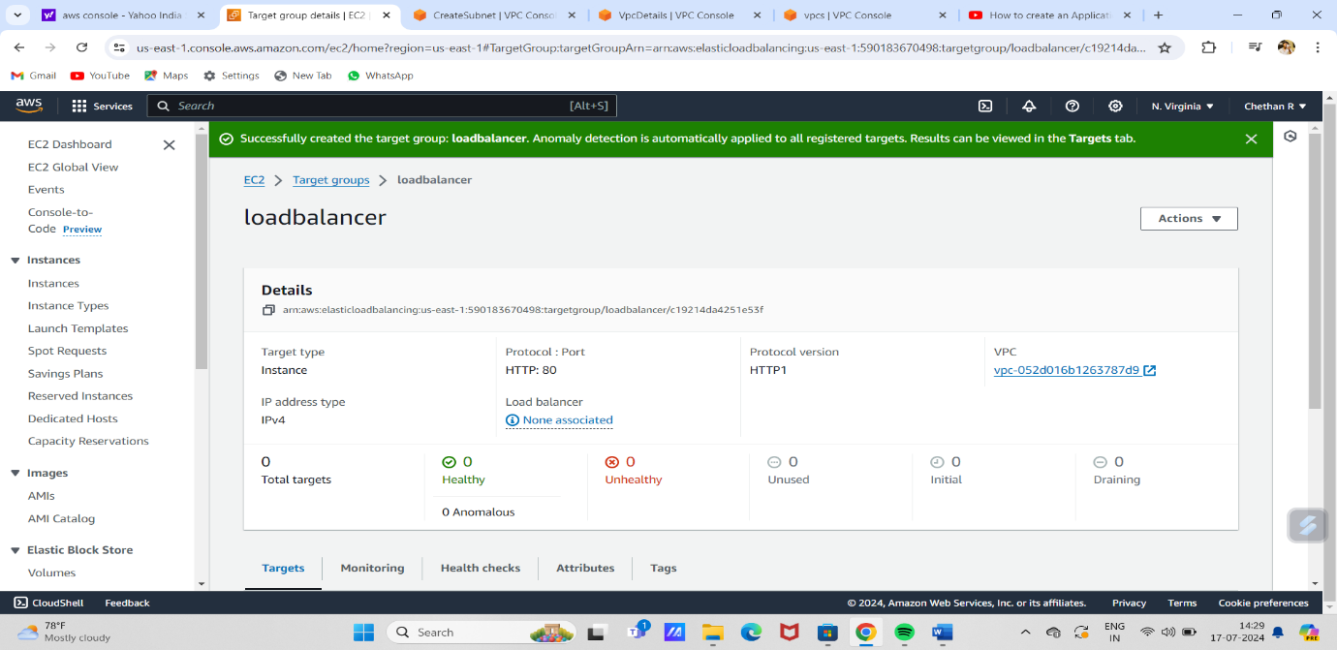

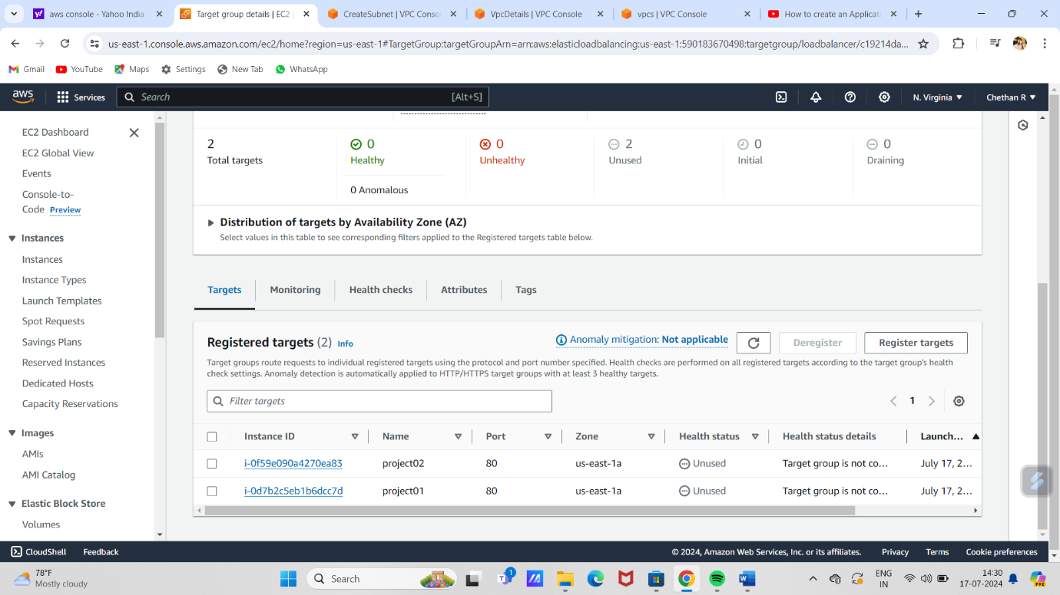

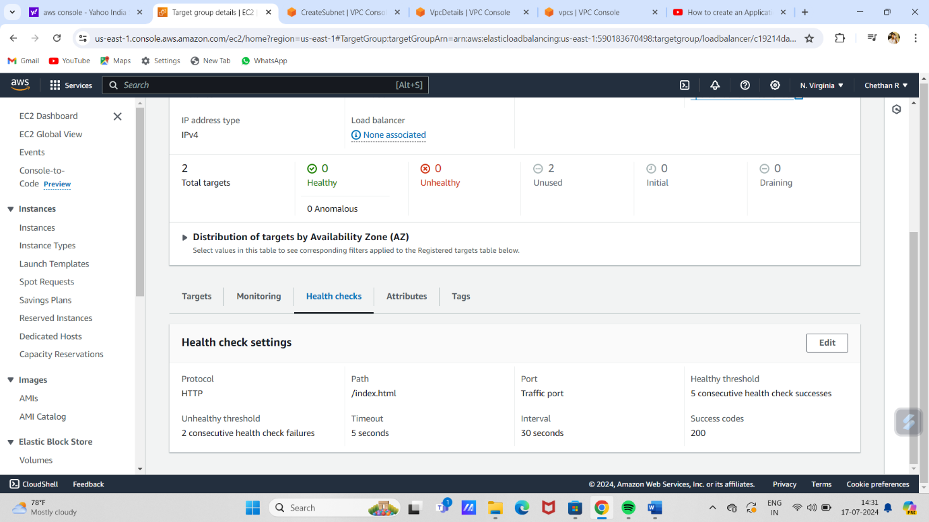

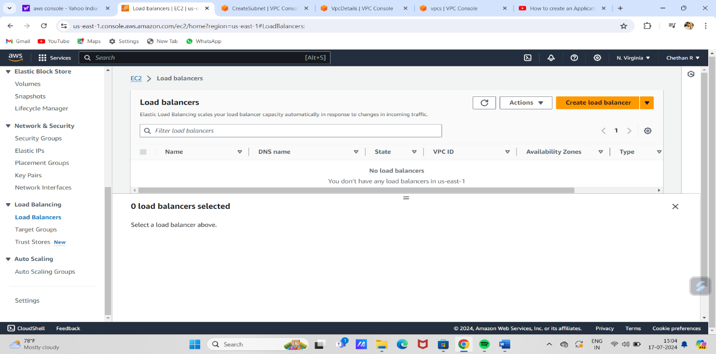

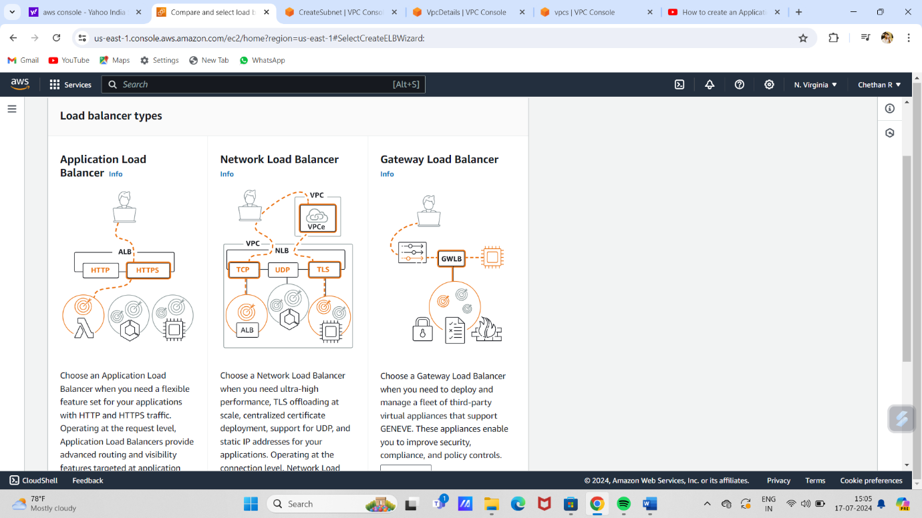

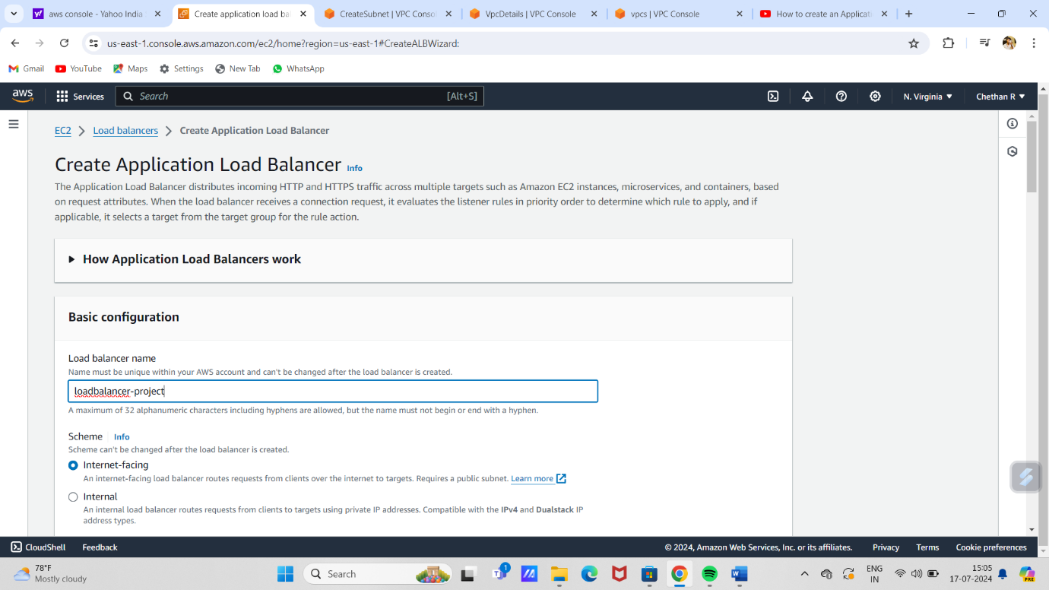

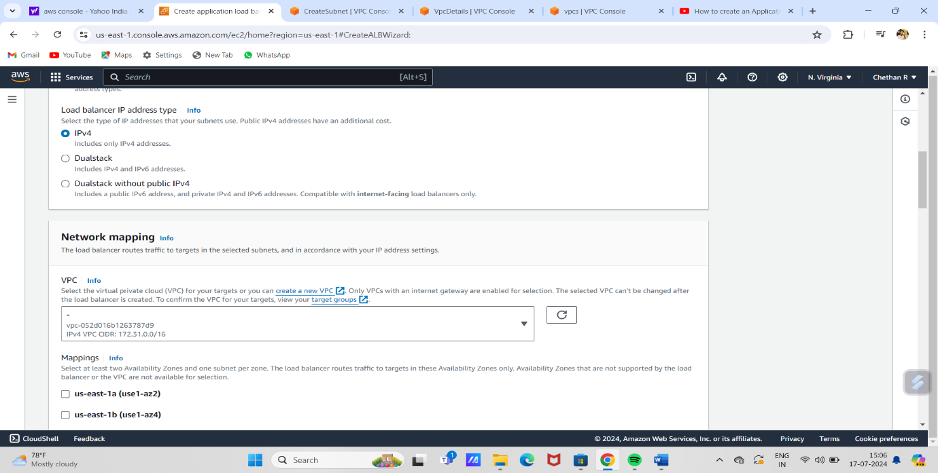

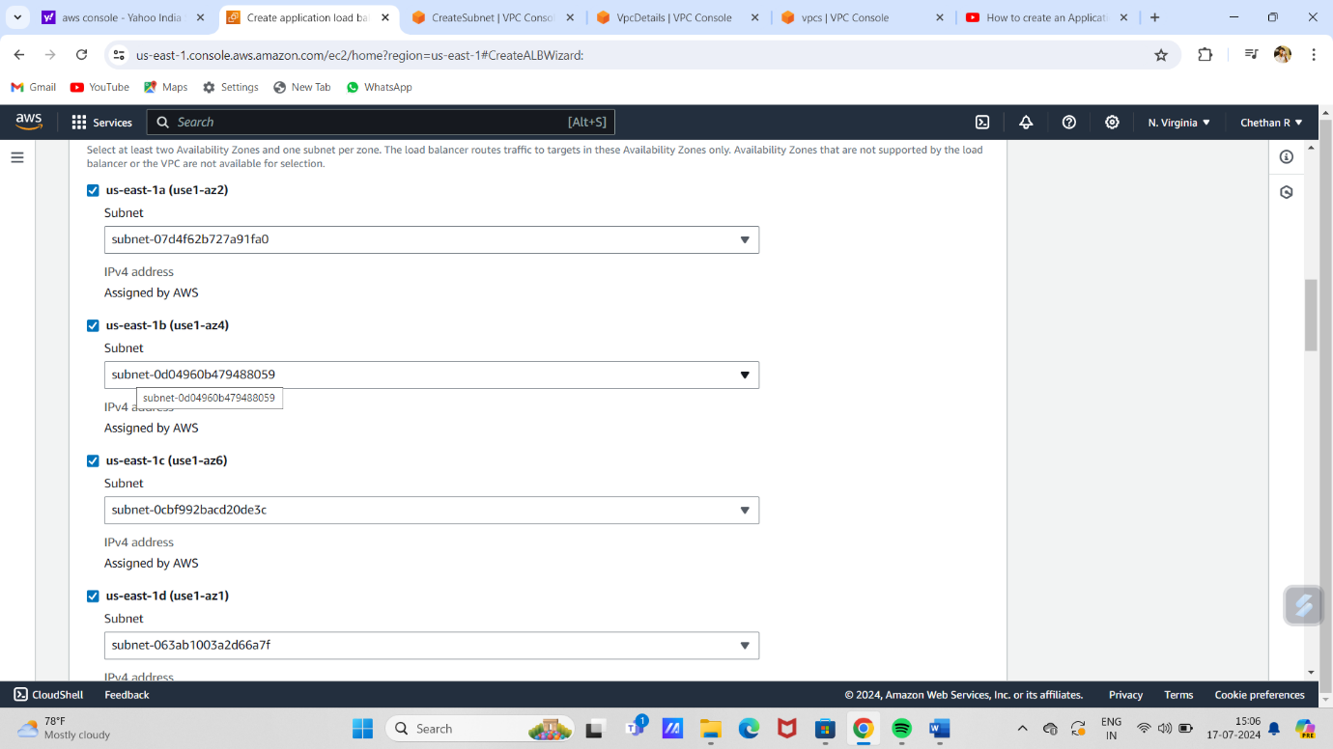

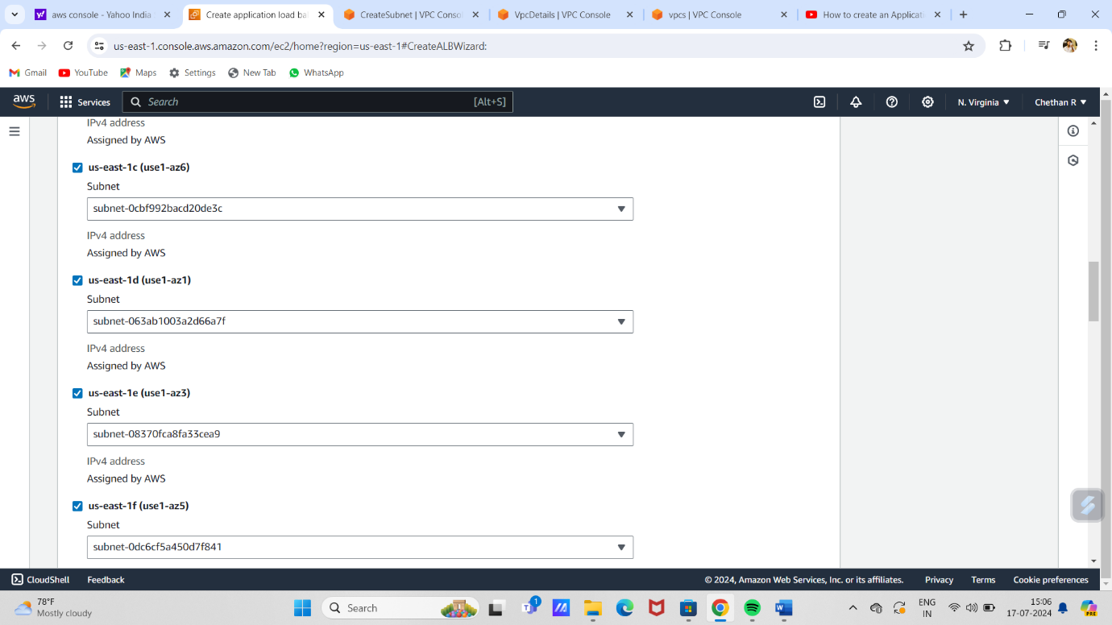

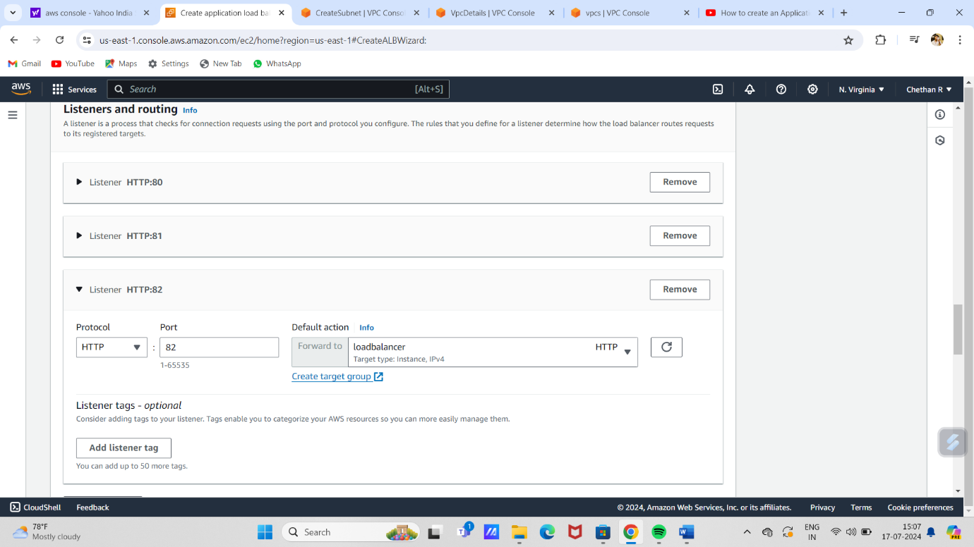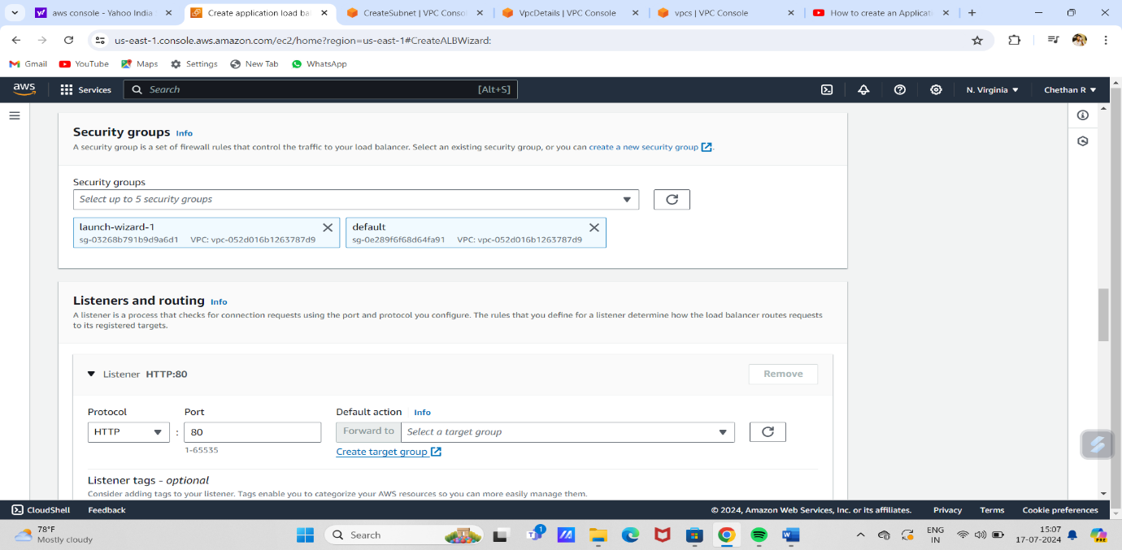

# 

# 

# 

# 

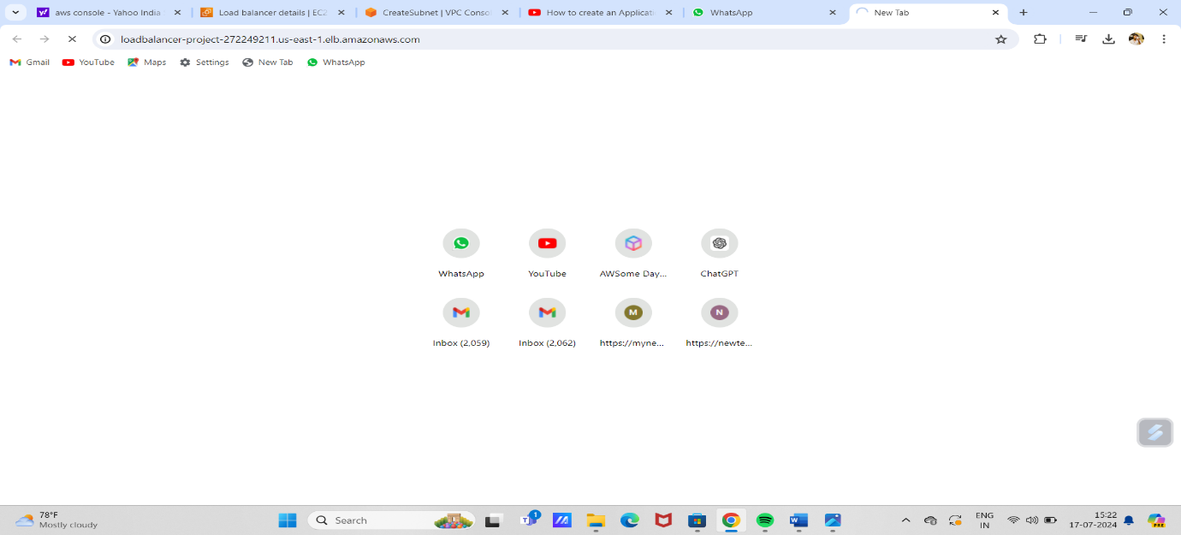



Autoscaling:

Steps to create autoscaling:

1. Sign in to the AWS Management Console and open the Amazon **EC2 Console.**

2. Go to auto scale and create **auto scaling.**

3. Give the autoscaling **name**. And **launch the templet**.

4. In templet **give name** and **description.**

5. Click on quick start and select **Linux machine.**

6. Give **t2.micro** in instance type.

7. select the **key pair**.

8. Then click on **create security group**. And **name** the security and **description**.

9. Go to advance details in **user data** give **the data.**

10. Then **launch templet**.

11. Next go to action set **default version.**

12. Then **choose** templet that you create.

13. select **all** **available zones**.

14. In load balancer choose option **attached to new load balance.**

15. Next enable **application load balancer.**

16. In load balancer scheme choose option **internet facing**.

17. In listeners select **target group**.

18. In health check enable **elastic load balancer**.

19. In advance setting enable **metrics option.**

20. click on **next three** times and click on **create auto scaling.**

21. Now to go security group. And **name** the group and **description.**

22. click on **add inbound rules**. Allow **all traffic** in type and allow **anywhere IPv4** in source.

23. Now click on **create .**

24. Now click on **security id** and **edit inbound rule**. **Add rule** and type **ssh in type** and **anywhereIPv4** in source.

25. Again, **add** one more and choose option **all traffic** in type and **copy the security group** **id** that you created and **paste in source**. Then save rule.

26. Now go to **load balancer** and click on id click on **action** choose **edit security group**.

27. Now **remove** auto scaling security group and **add load balancer security group**...

28. Now see whether auto scaling is running or not.

29. If running click on it and go to **instance manager** and click on instance id .

30. Now open load balancer **copy the DNS** and **paste** it in **new tab.**

31. Now its shows **IP address.**

32. Now go auto scaling click on it and in **auto scaling** **create dynamic policy.**

33. Select **simple scale**. Name it and **create cloud watch** **alarm**.

34. Select **metrics**. Go to ec2 **in ec2 go** for **pre metrics.**

35. Go to instance tab **copy instance Id** and pasty it in **search box.**

36. Now search for **CPUutilization.**

37. select **metrics** and choose **greathan equal** .

38. select 30 and click on **next**.

39. Here **remove notification** and click on **next.**

40. Name it and **save the alarm**.

41. Go to auto scaling click on dynamic now **connect to EC2**

42. click on **connect.**

43. Now give command **sudo yum install stress -y.** enter.

44. Give another command **sudo stress –cpu4 –timeout 600**.

45. Now you can see its install in it. Now you can observe the ipaddress.

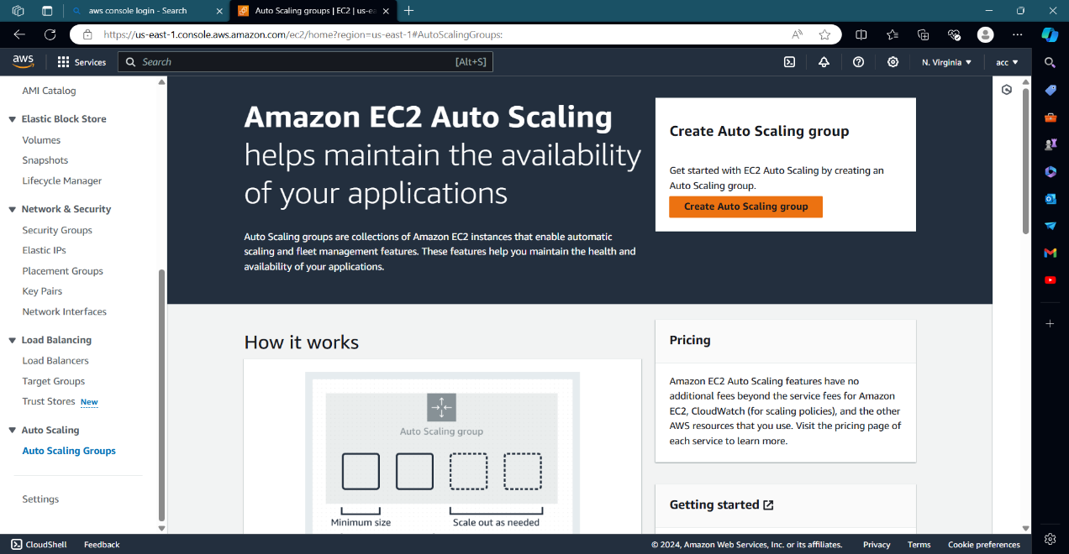

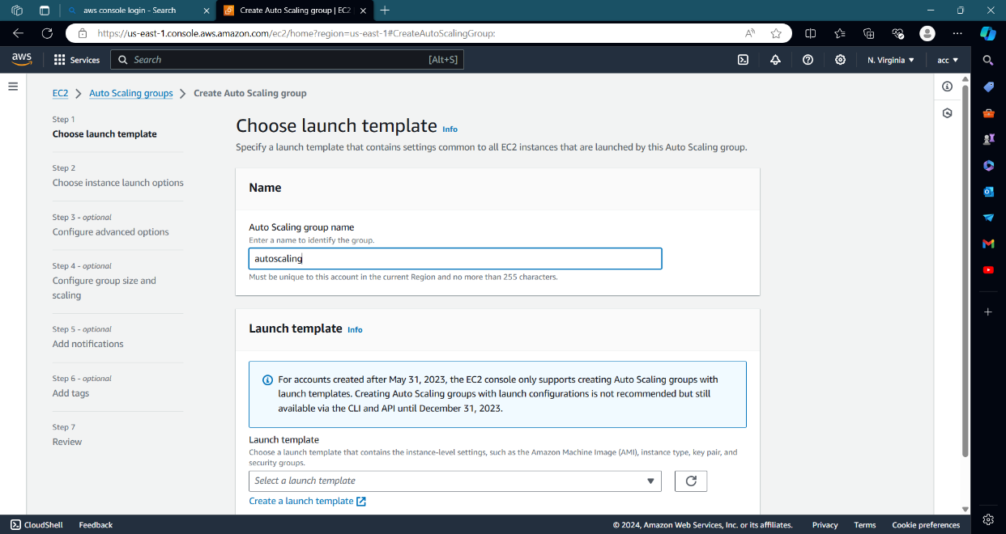

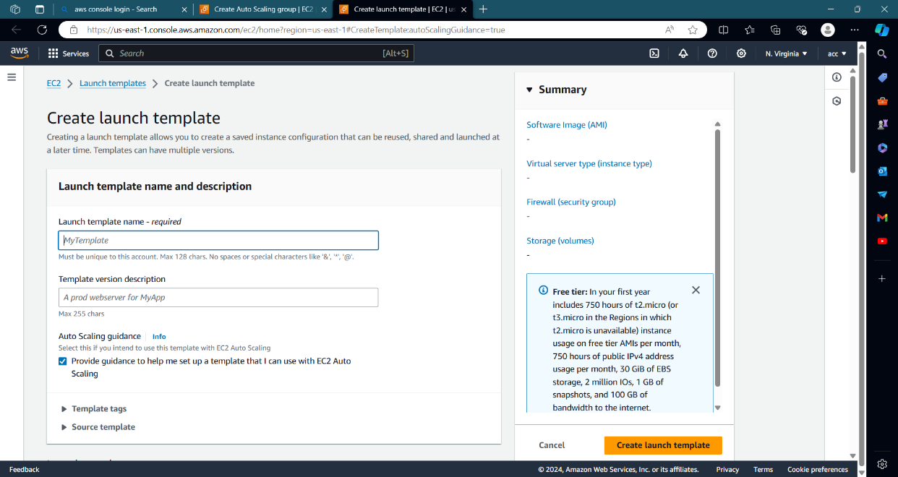

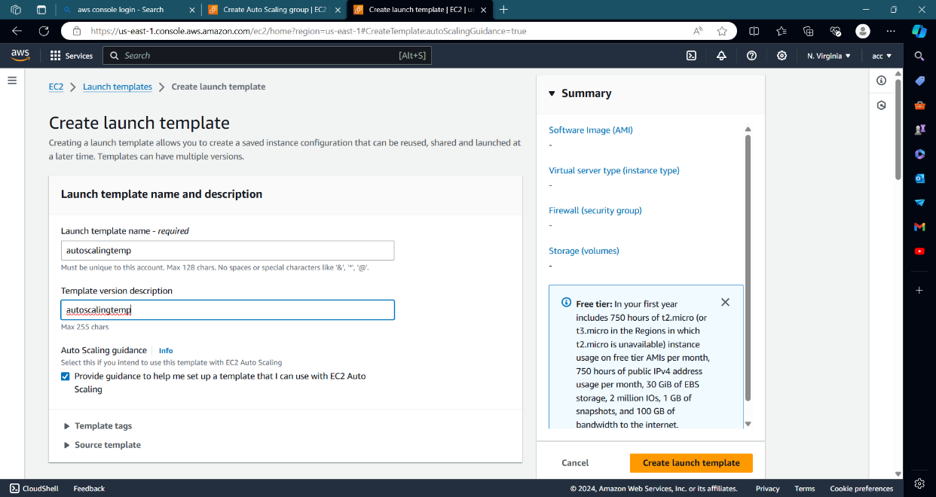

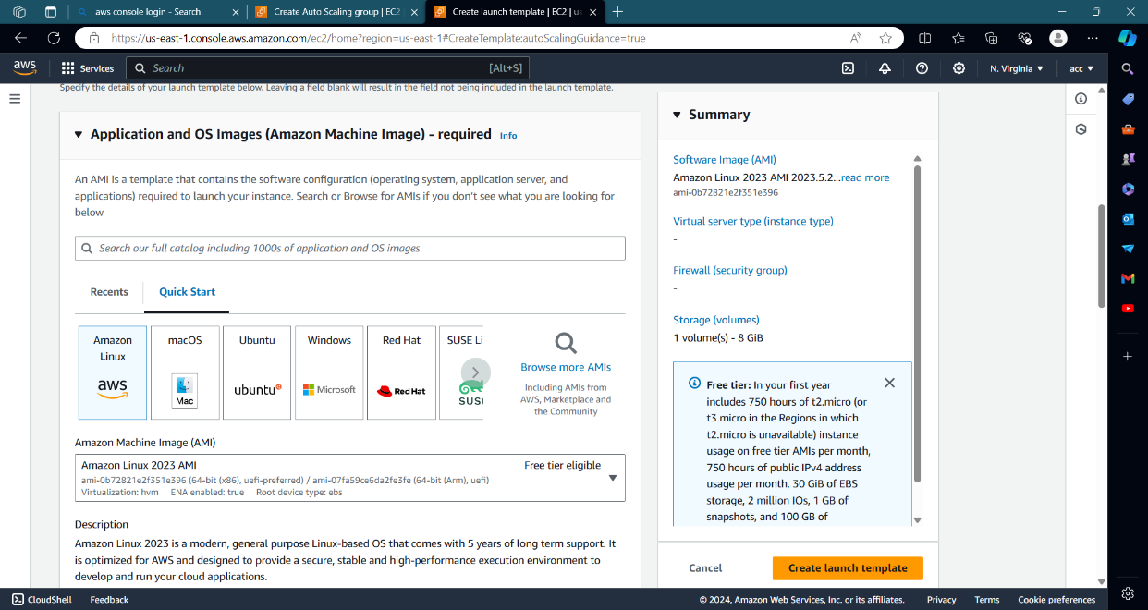

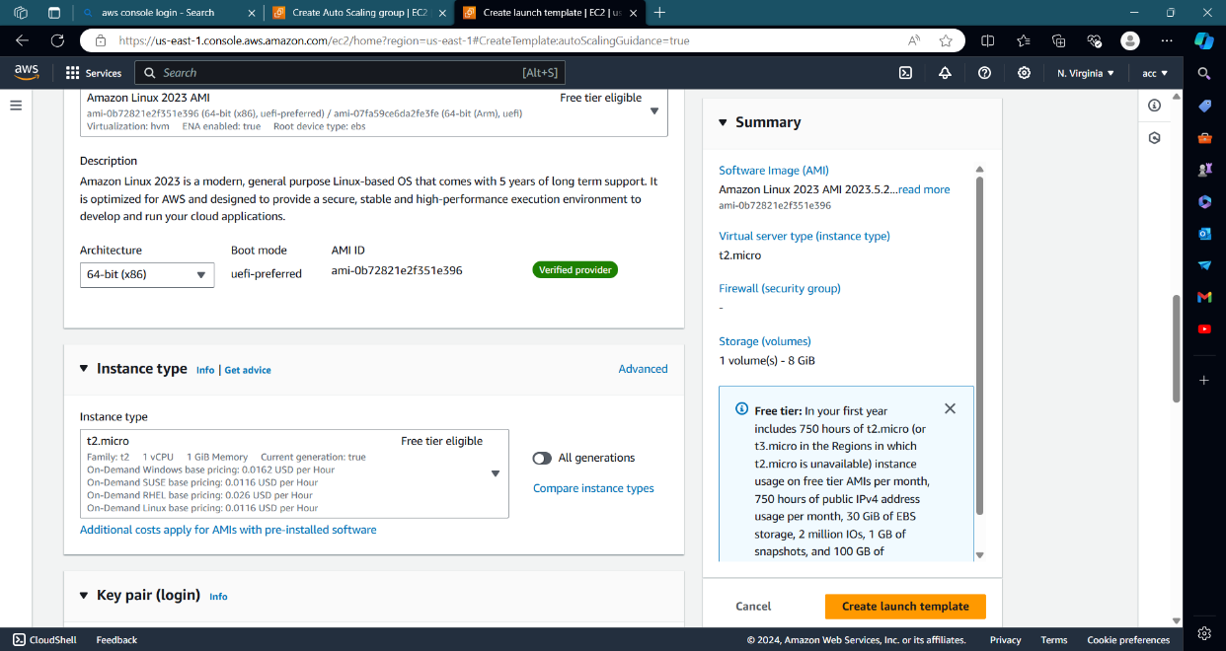

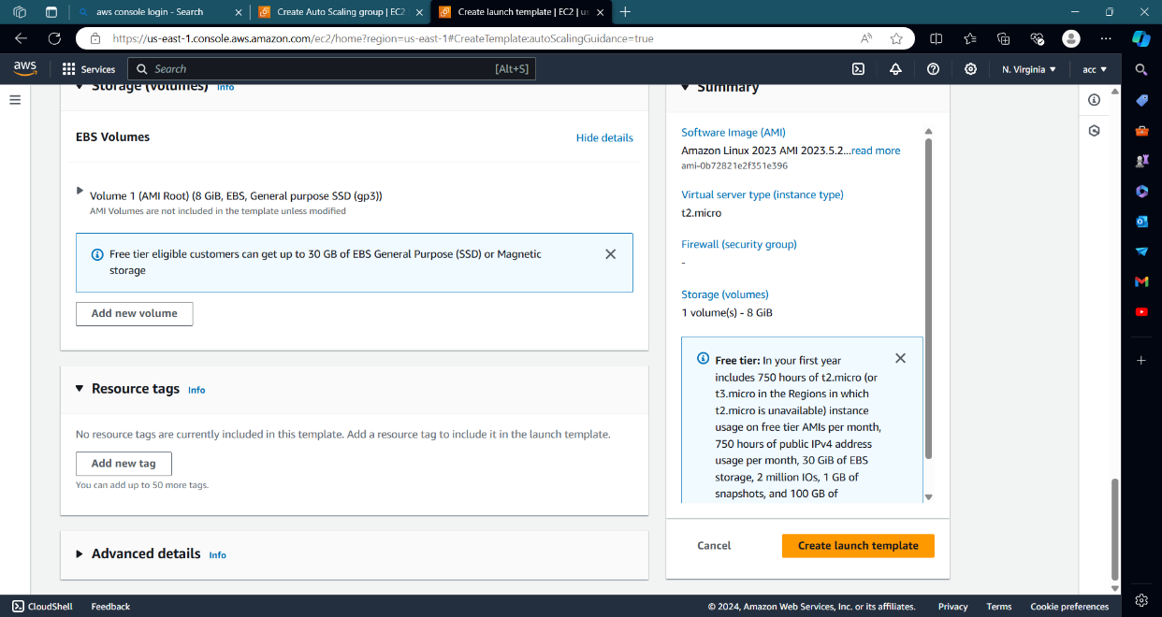

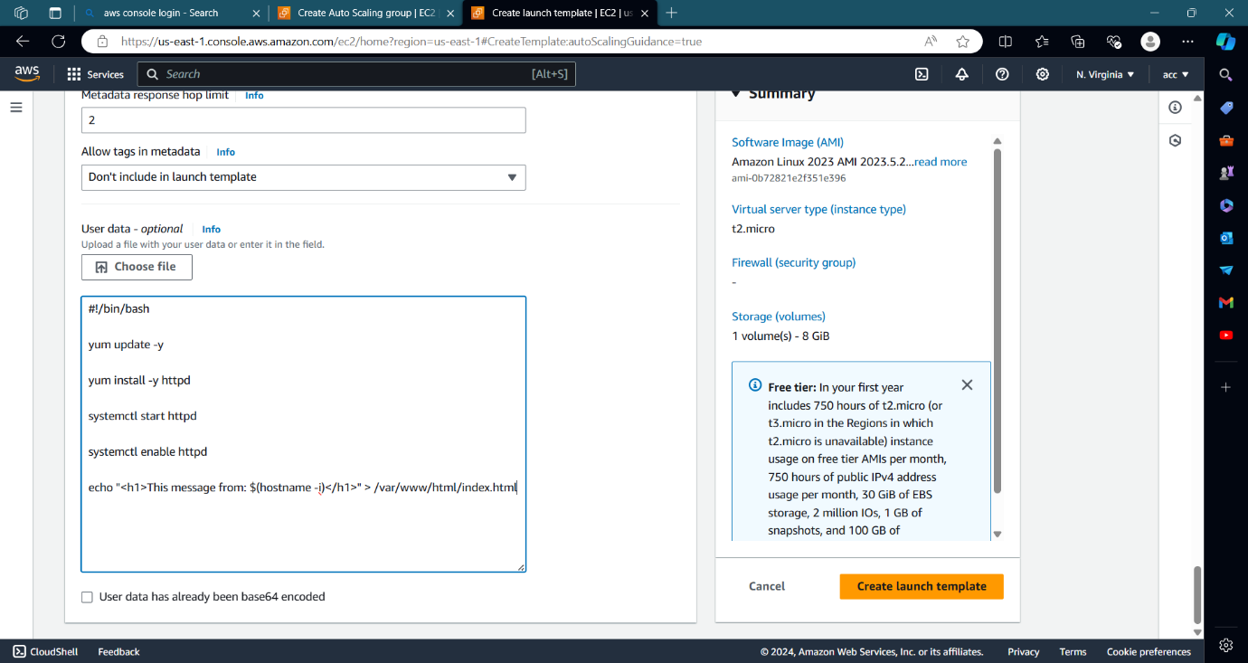

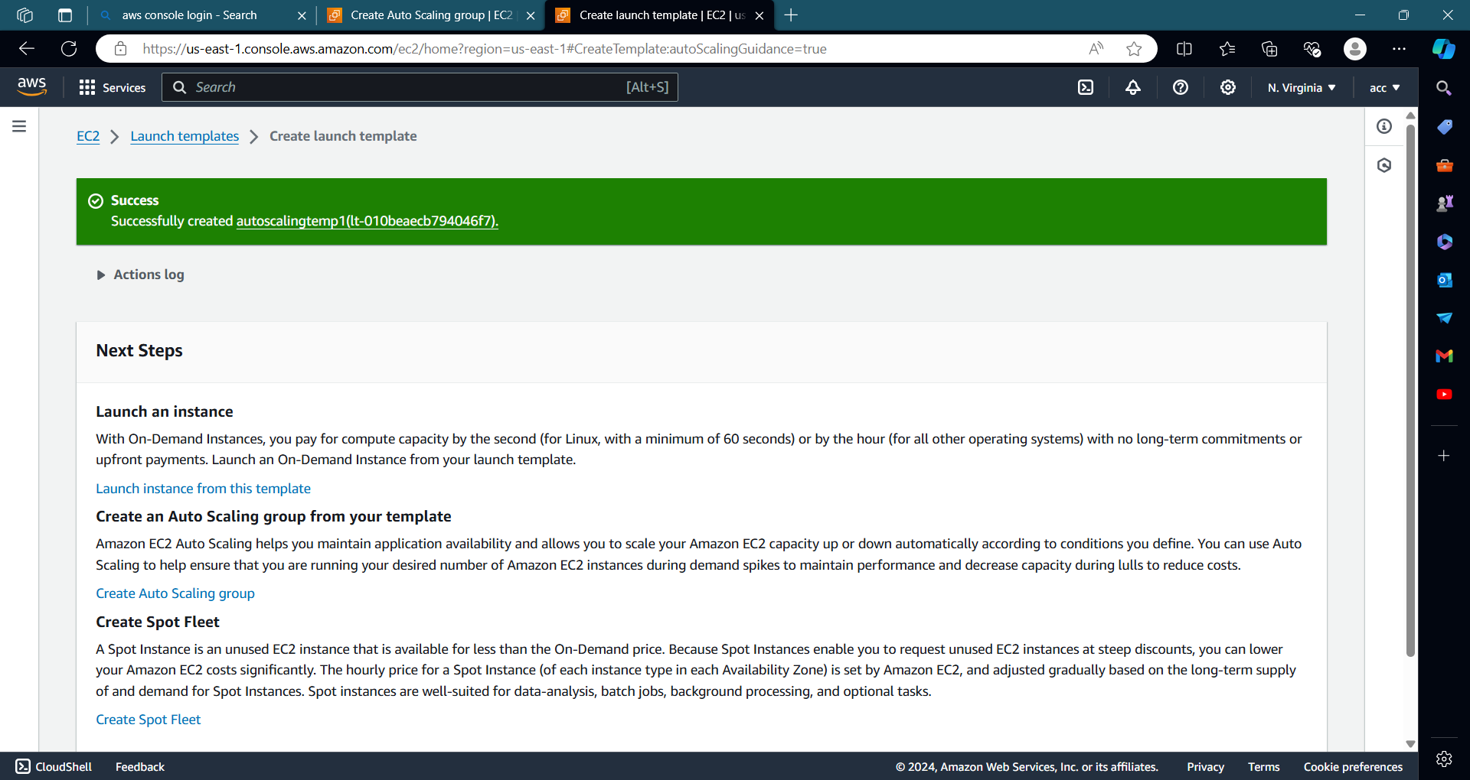

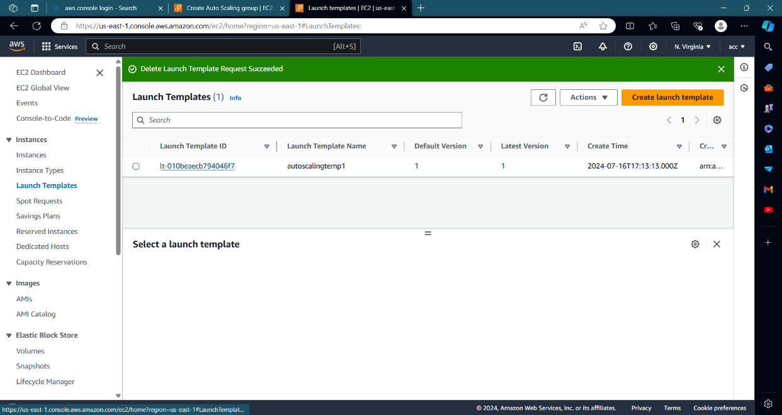

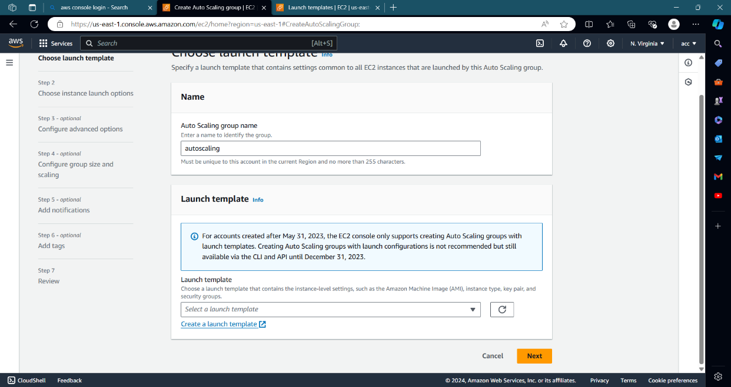

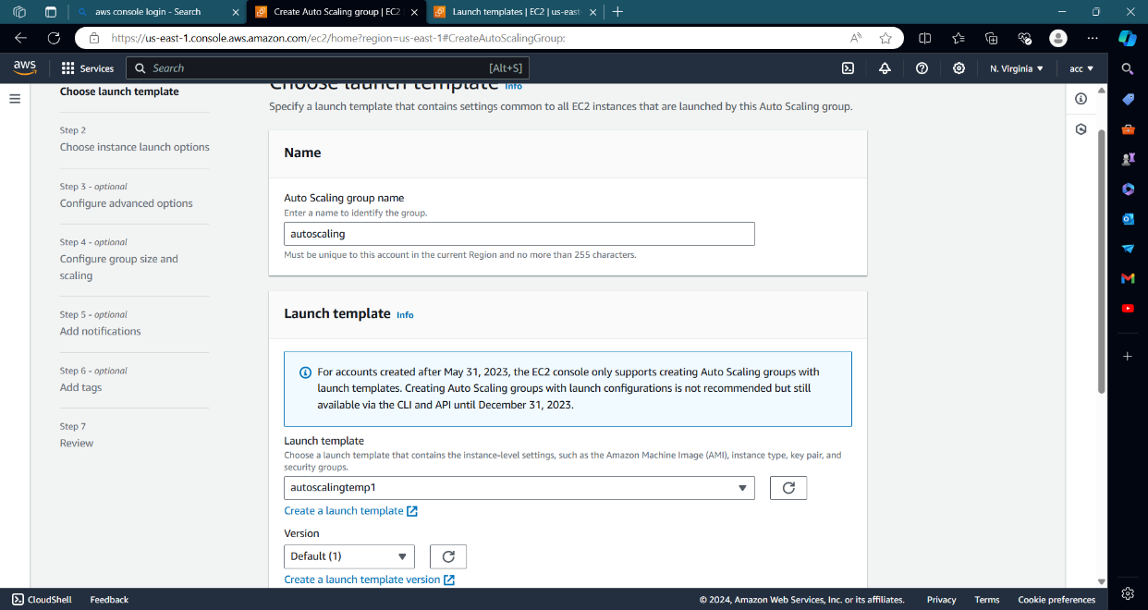

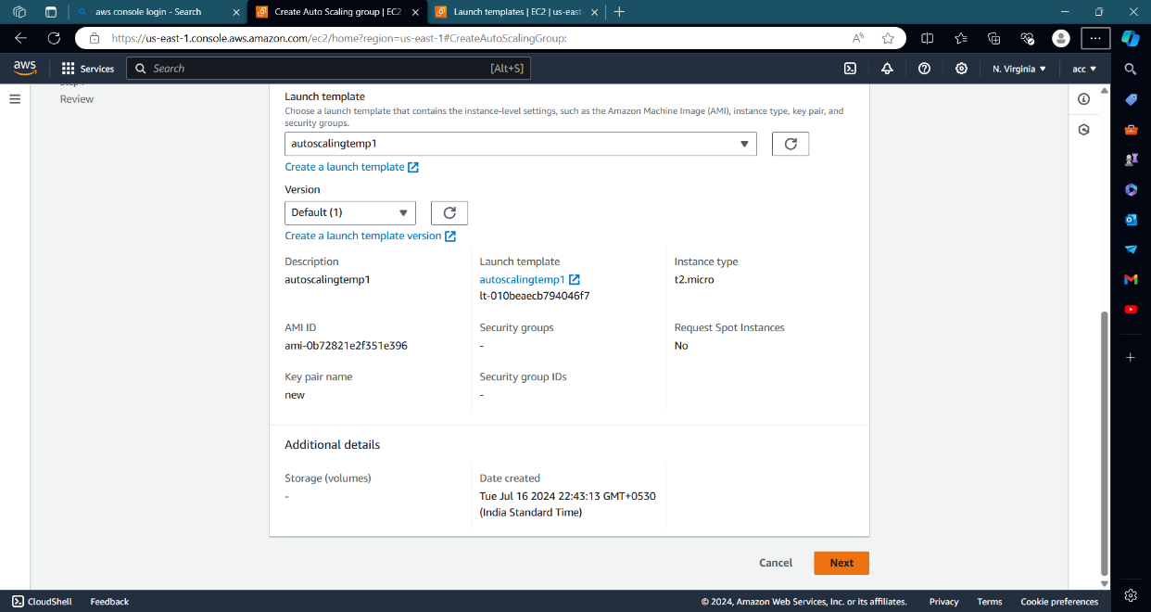

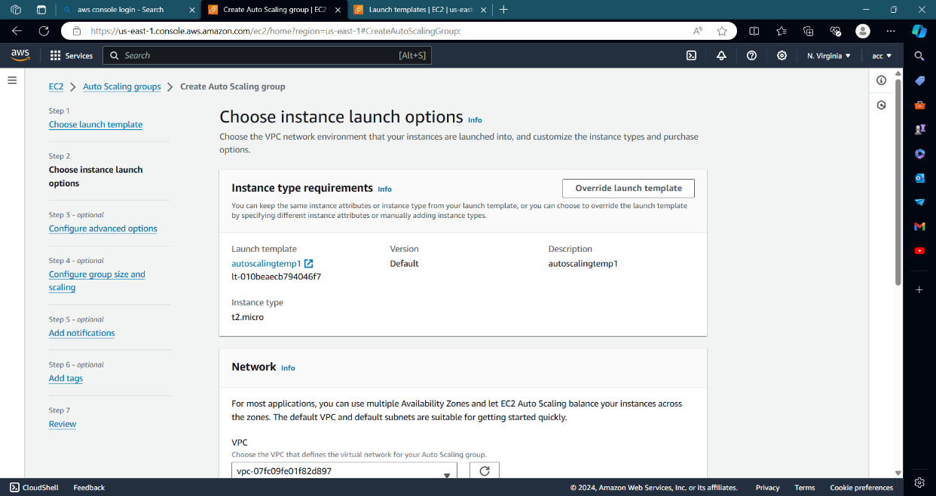

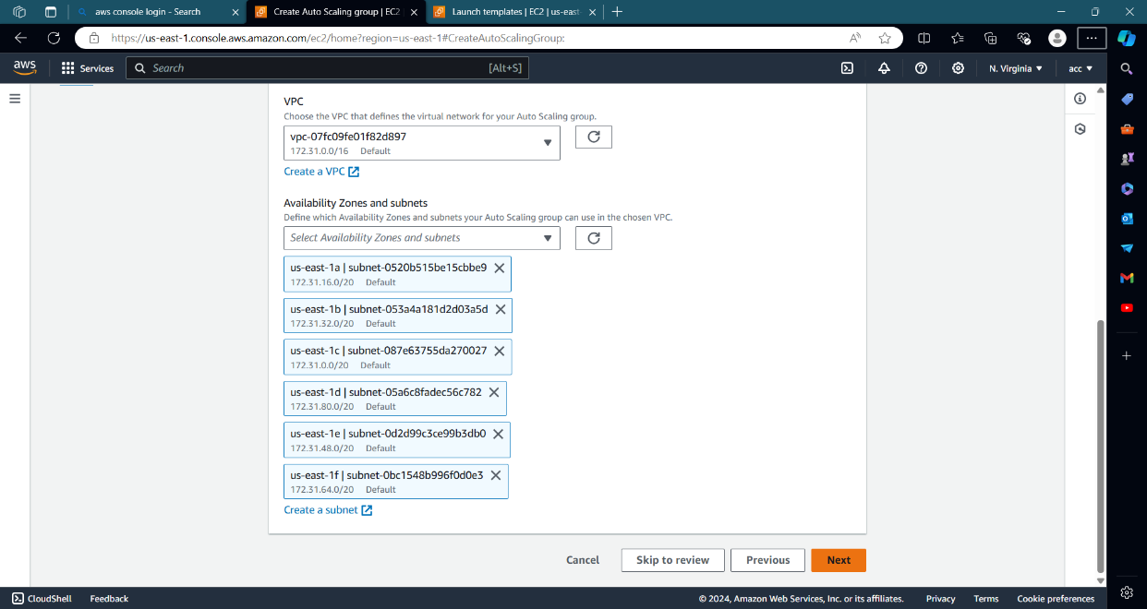

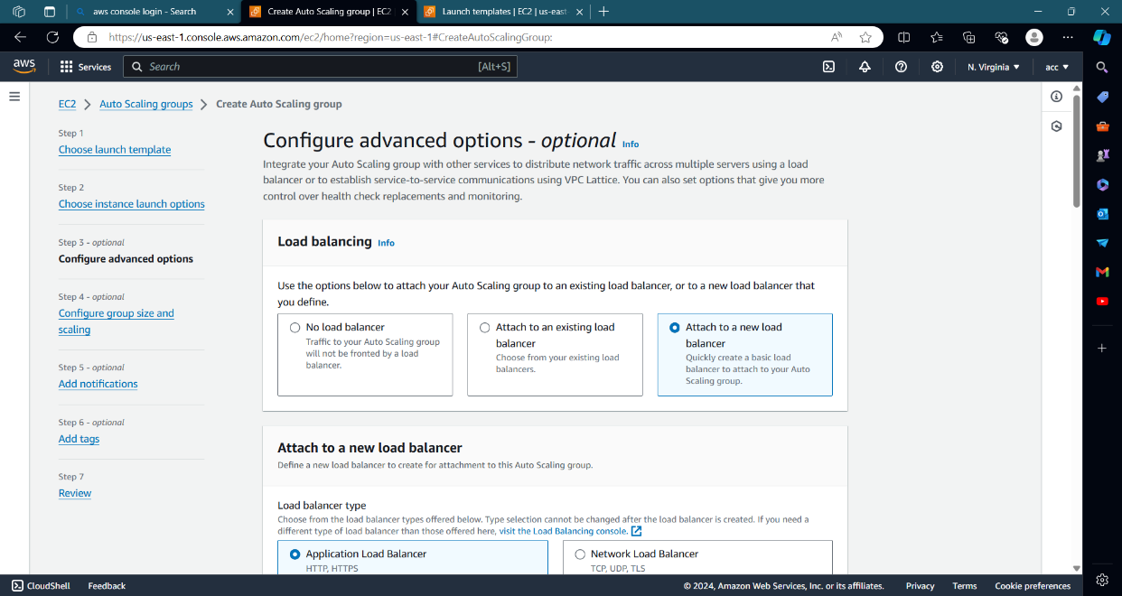

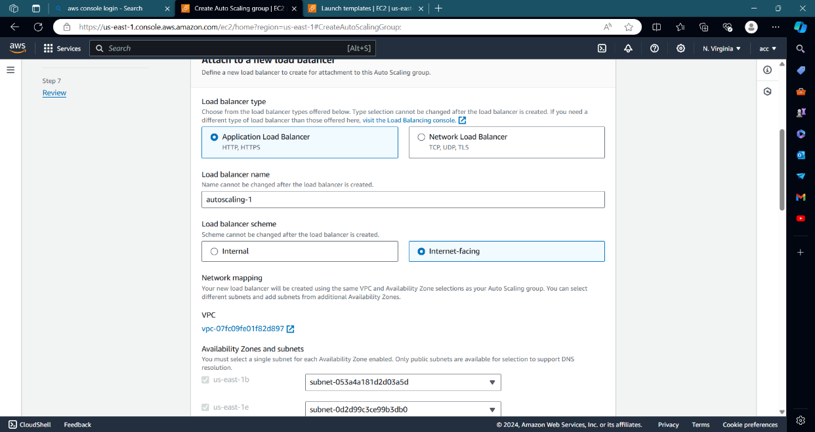

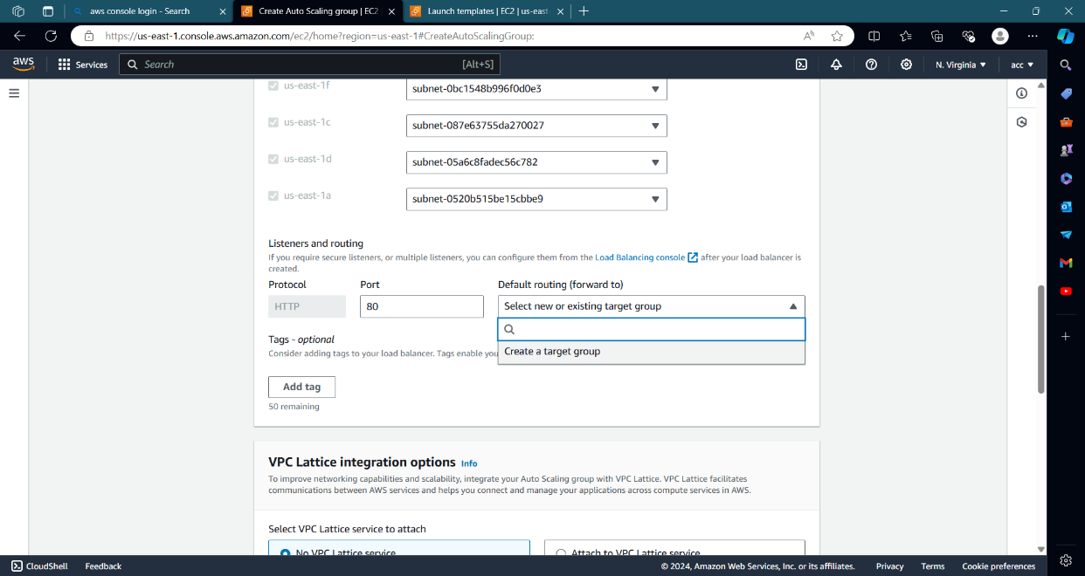

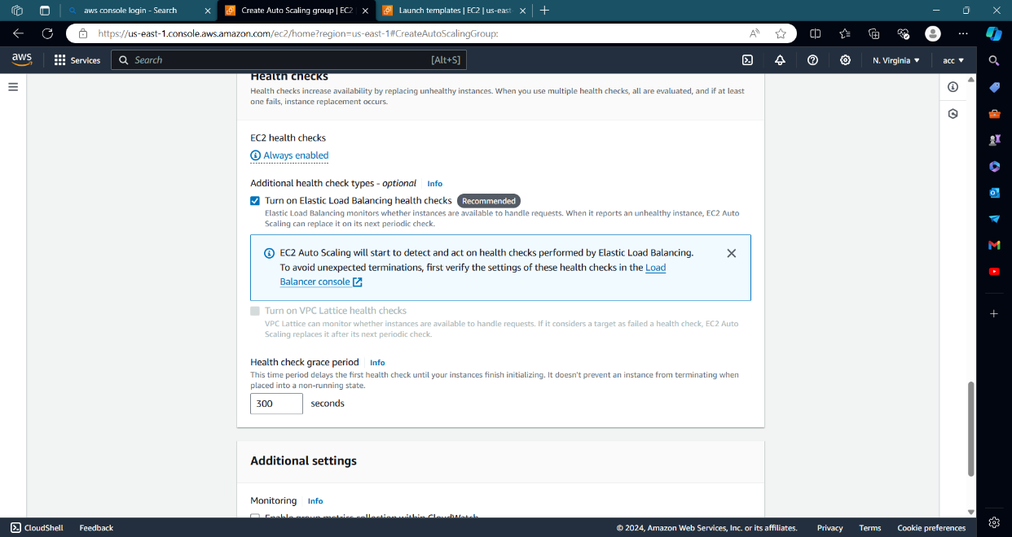

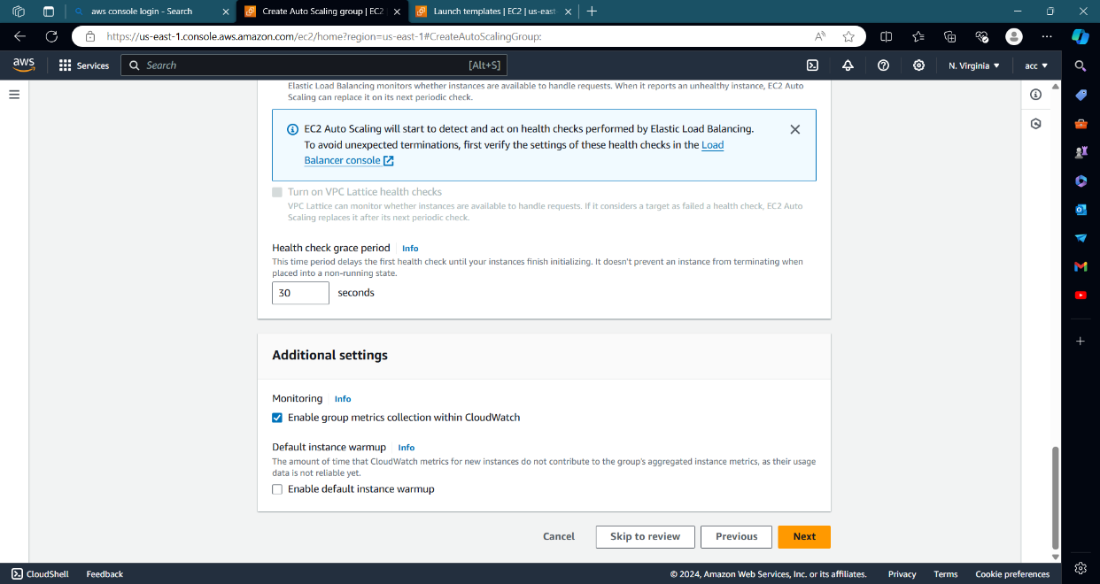

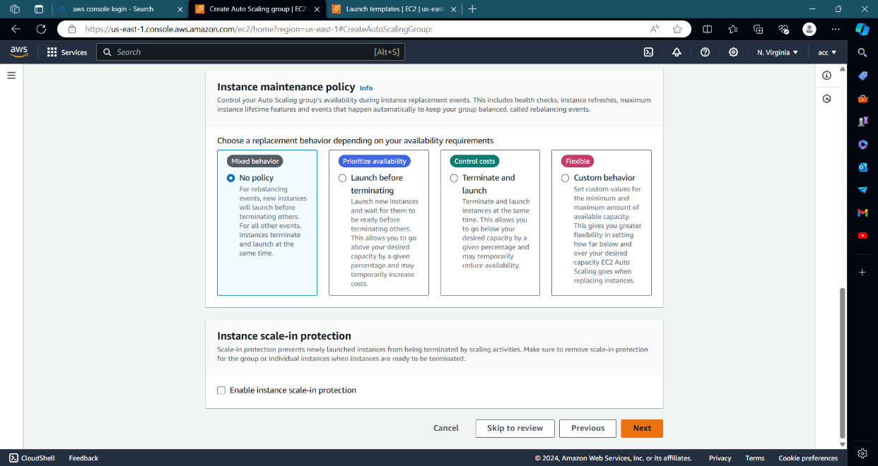

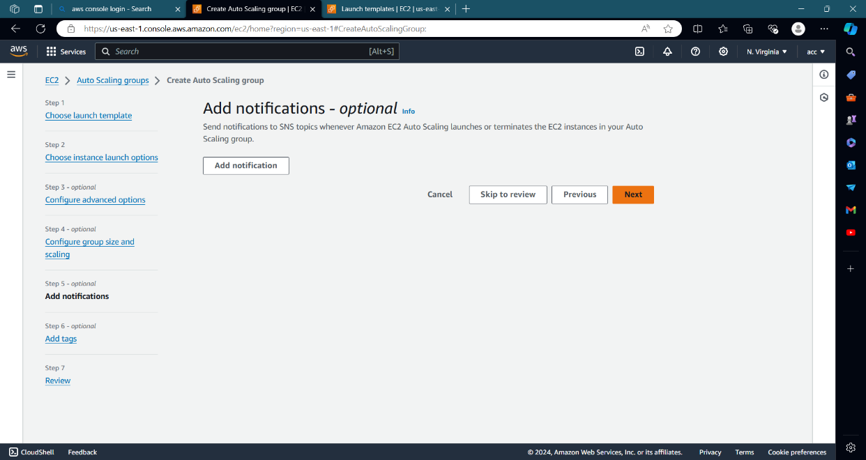

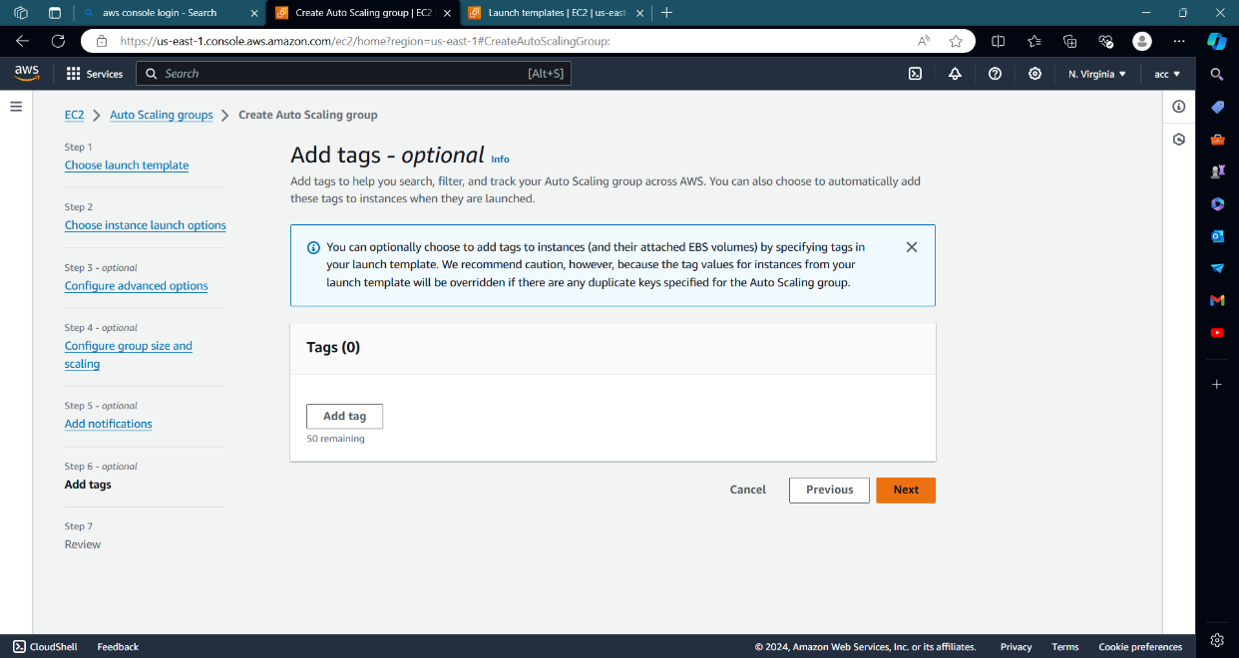

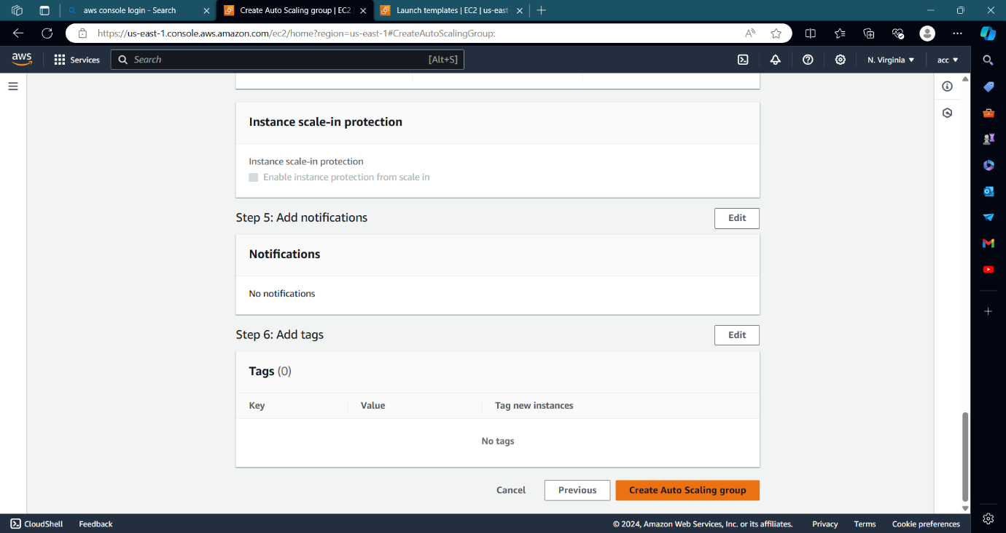

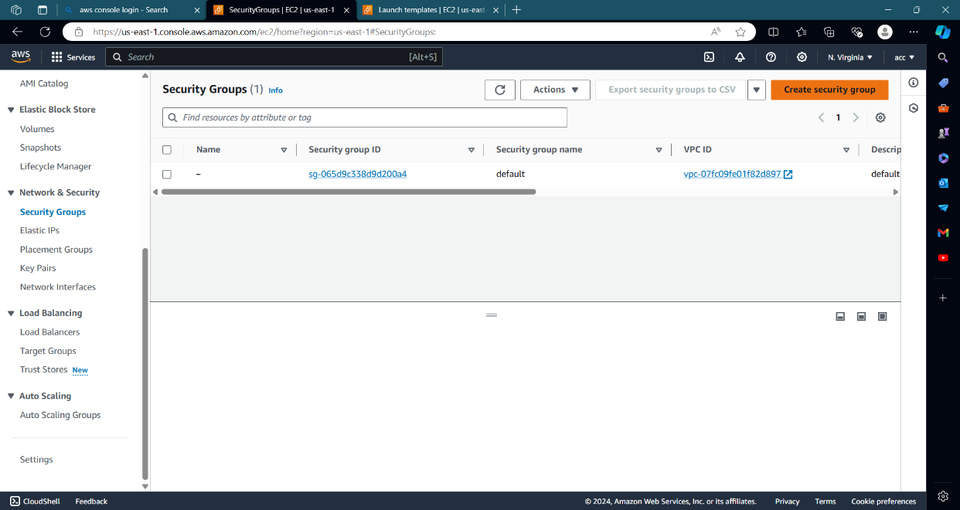

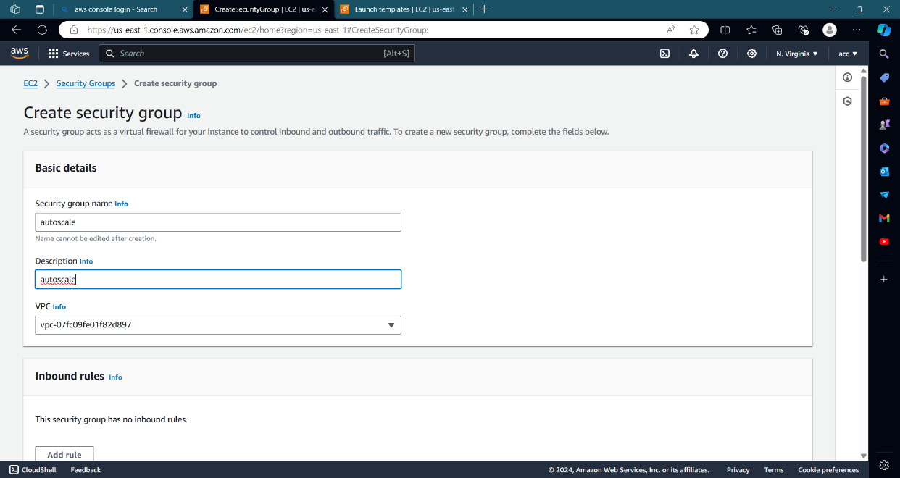

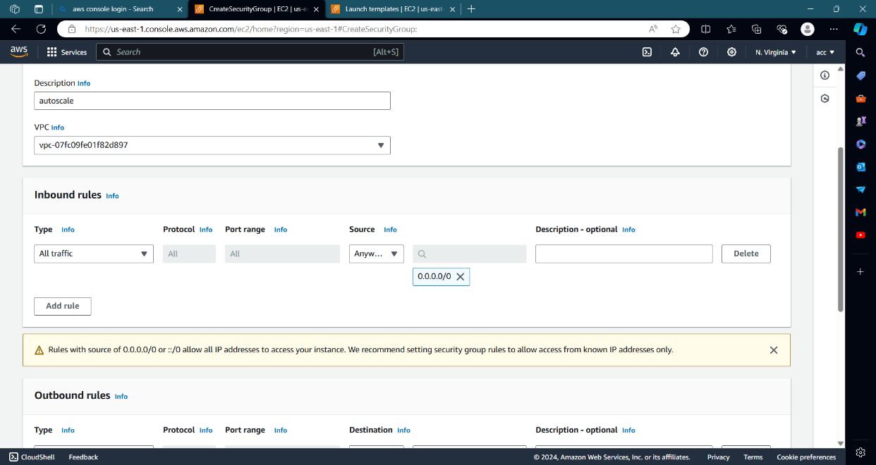

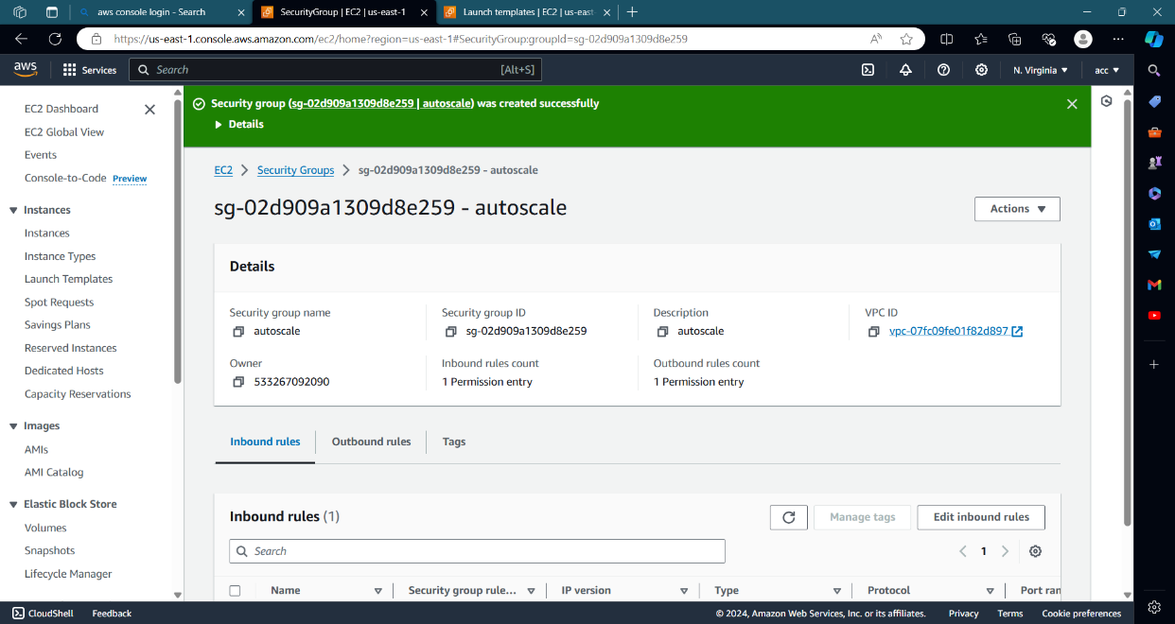

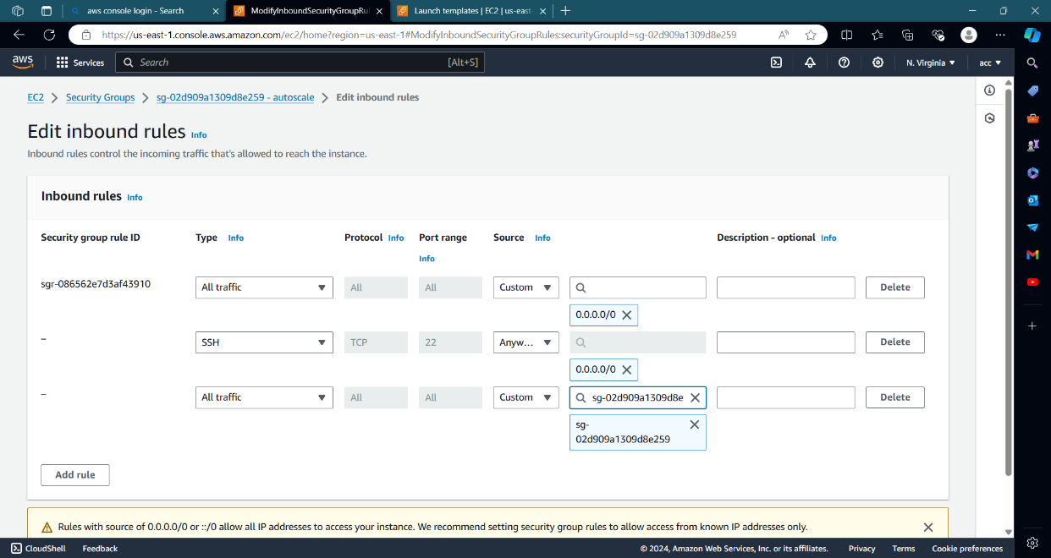

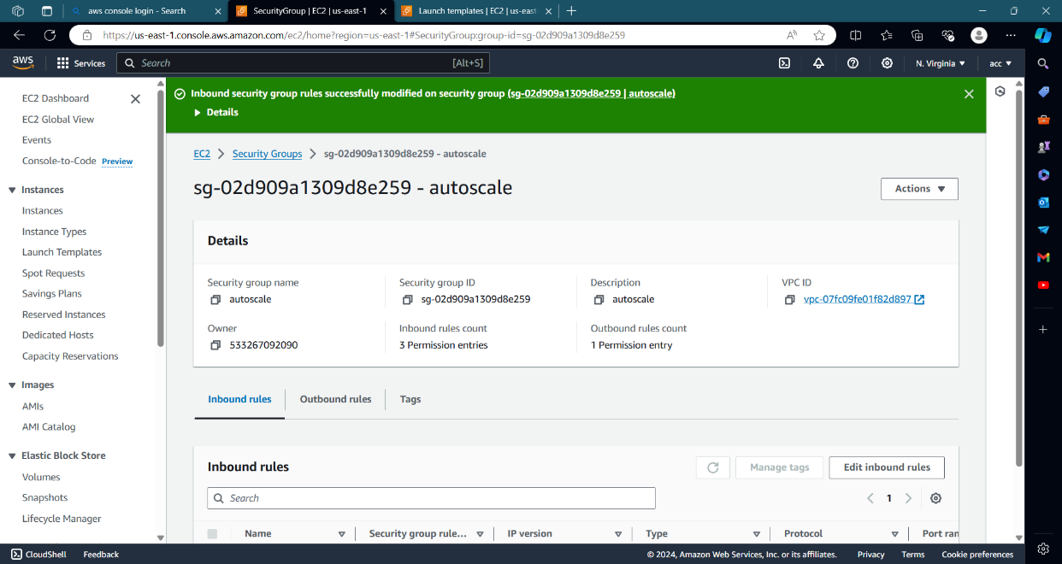

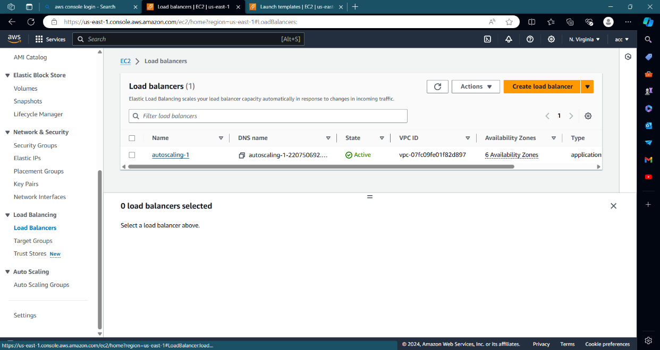

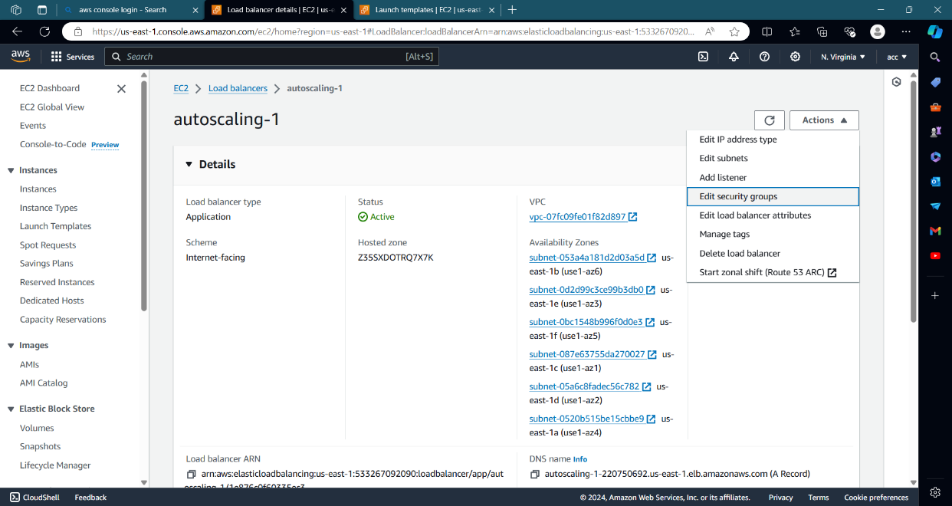

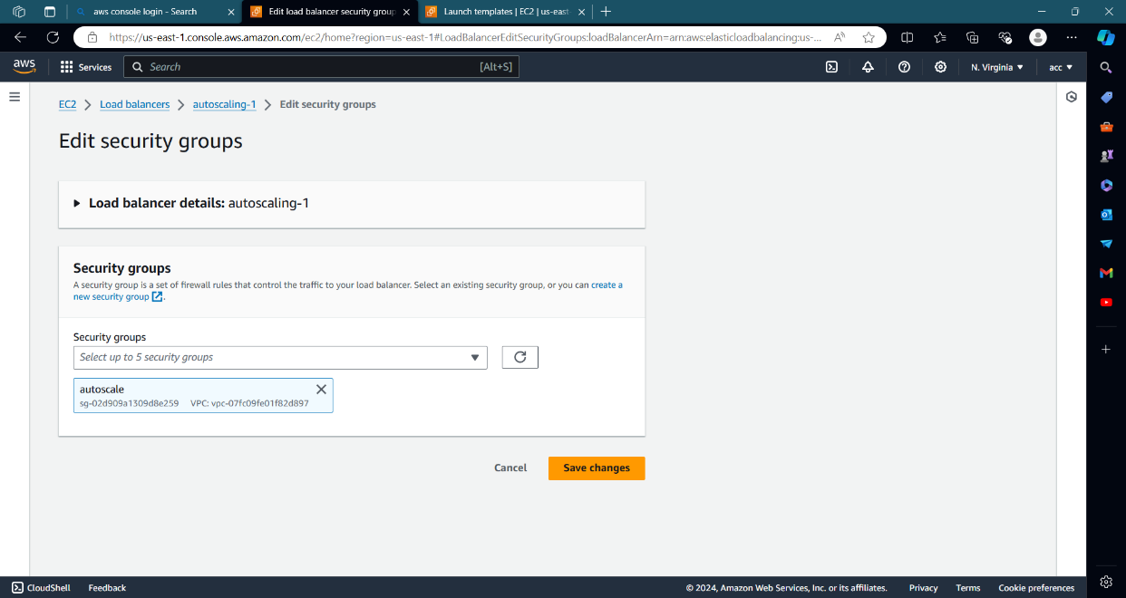

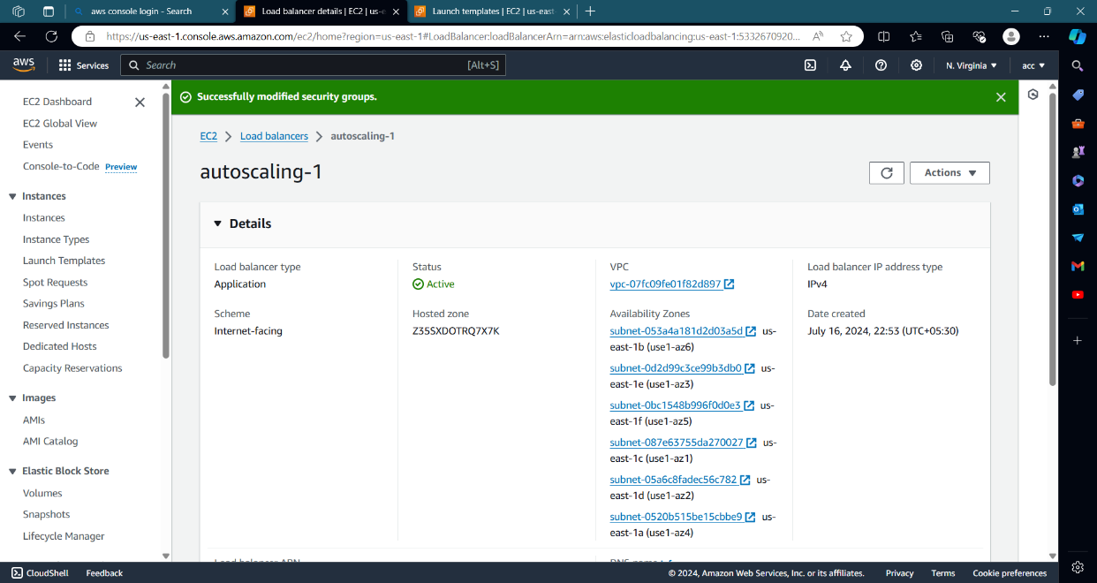

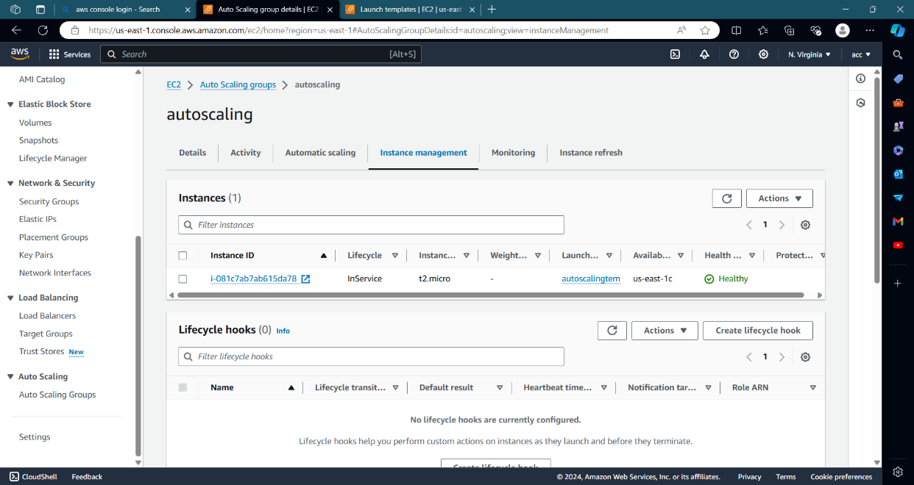

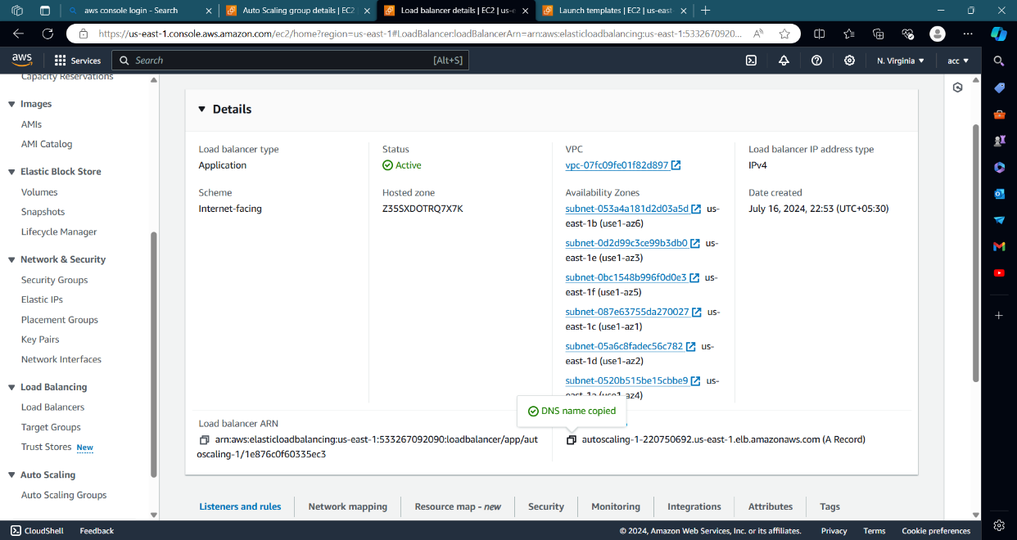

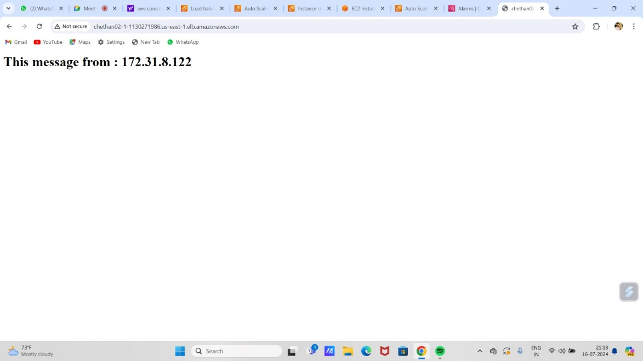

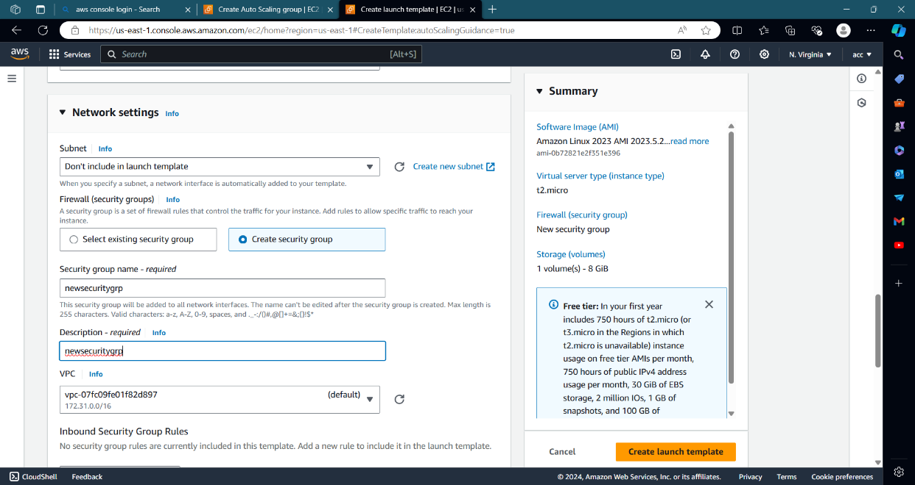

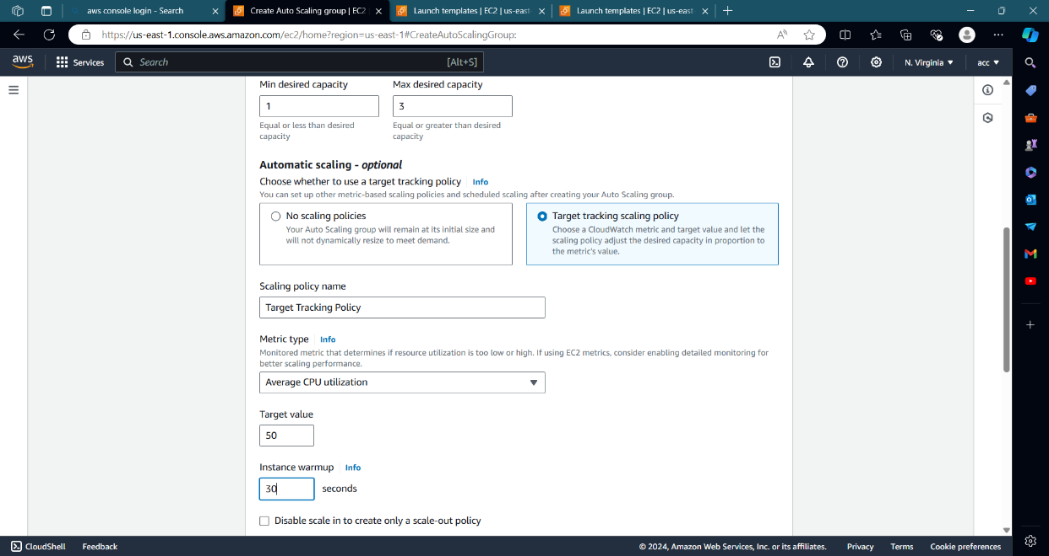

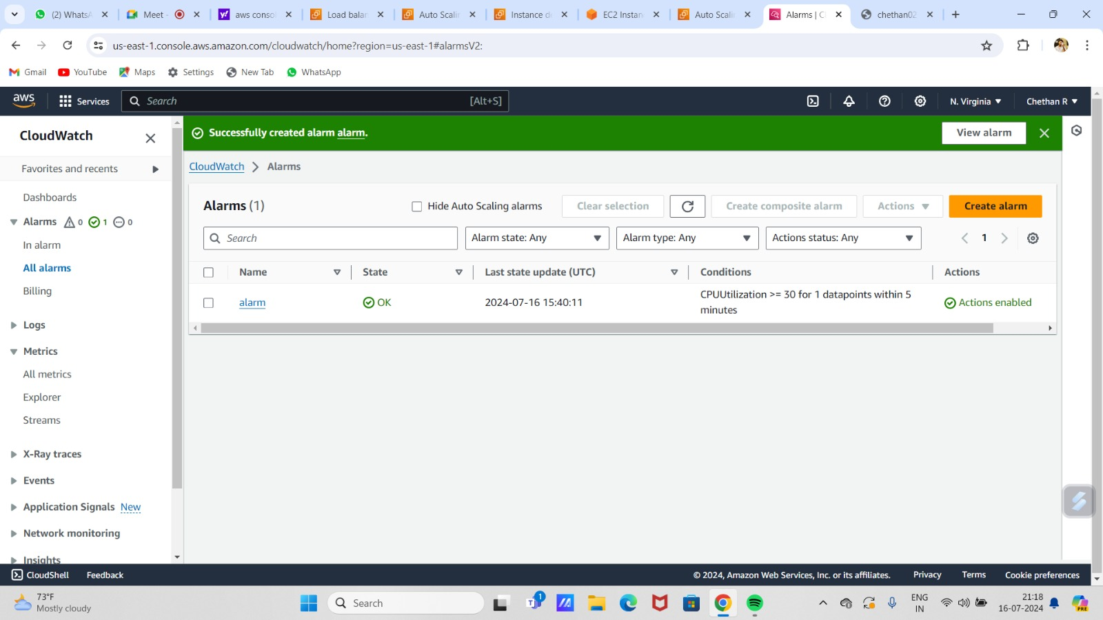

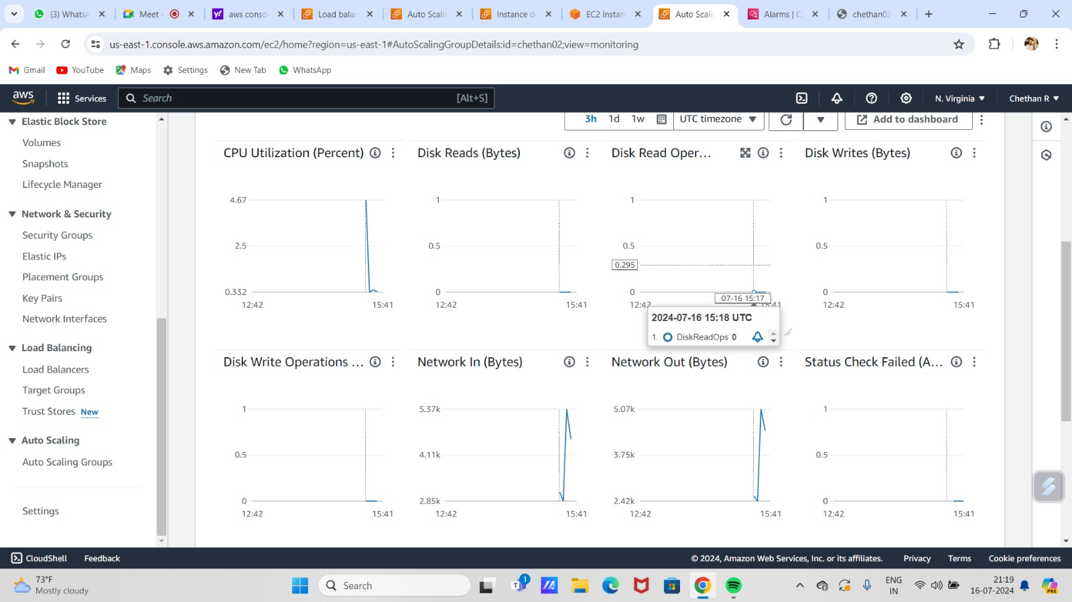

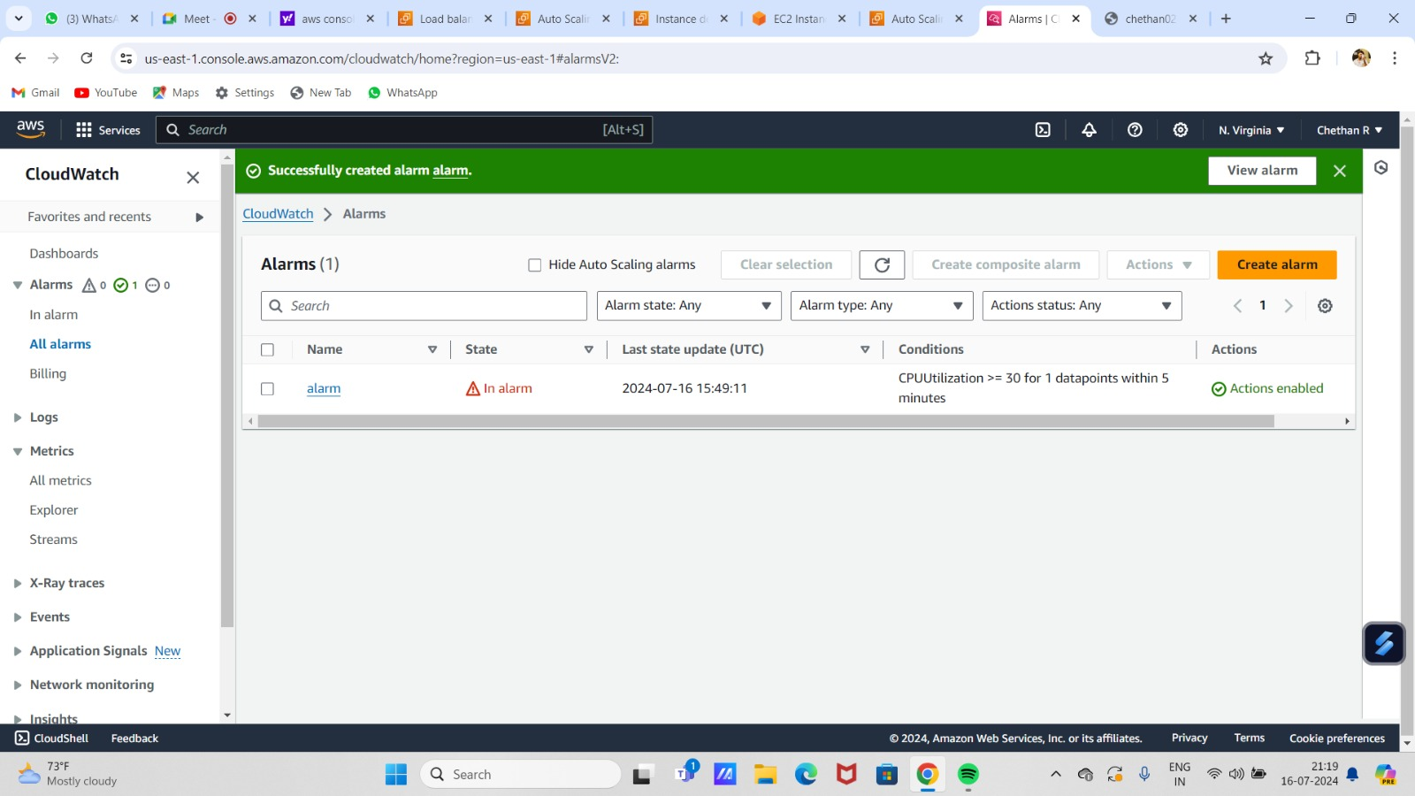

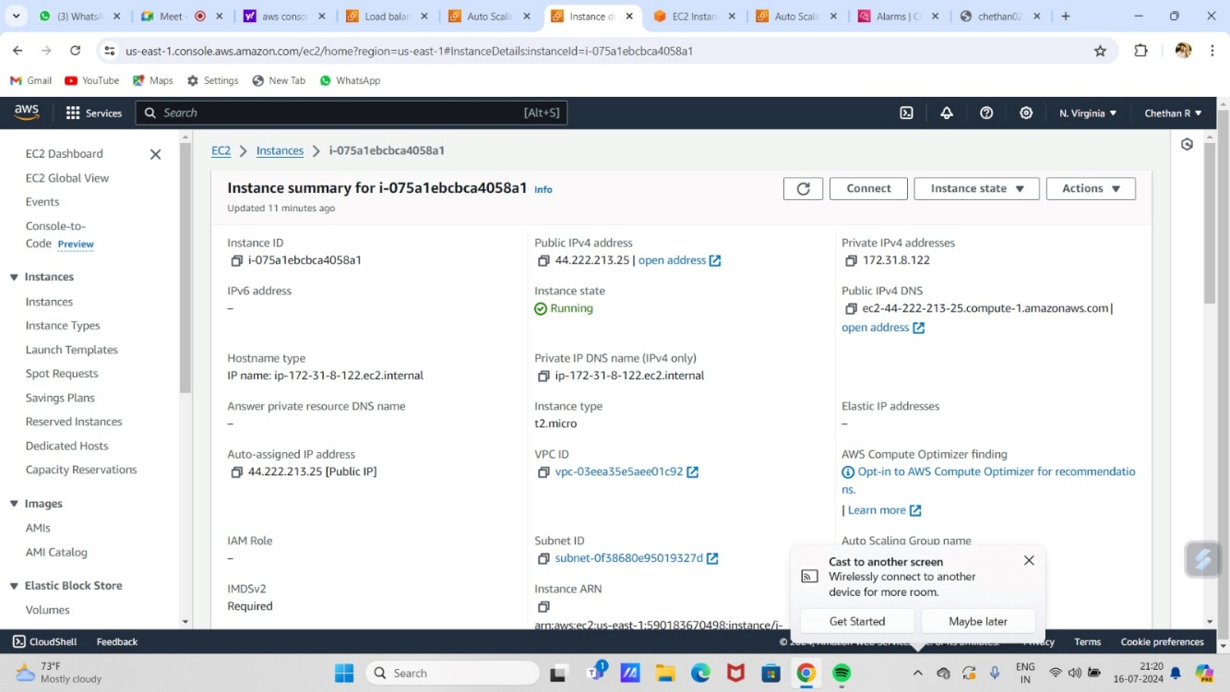

# 

# THANK YOU

# 